Logbook Set-Up:
- Label the front cover of the composition book with the following information:
  - Your first and last name
  - Charles R. Drew Charter School
  - 301 E. Lake Blvd, Atlanta, GA. 30317
  - (470) 355-1200
  - Teacher Name
- Leave the first page blank for your table of contents. This page will be the last thing you complete for your logbook after all entries have been made.
- After the table of contents, number the remaining pages of the logbook.
- Use tabs to separate the sections of your logbook.
Logbook Sections:
- Deadline Schedule: Write this schedule onto page 1 of your logbook. It will help keep you on track with due dates.
- Background Research: Include all notes taken while researching in the media center or online. This information will be used to write your research report. You should also record the source information for your works cited page. Do this for EVERY website, book, encyclopedia, magazine, or interview that you use for information. A minimum of 5 sources is required for this project. You must follow proper citation format (see sample section for guidelines).
- Problem Statement: Write the research question you have in statement form. The problem statement is the entire purpose for doing your research and completing your experiment.
- Hypothesis: After conducting research, write a hypothesis for what you think the answer to the research question is going to be. It is an “educated” guess in the form of a statement.
- Experimental Setup: Include in this section:
  - Materials: Make a DETAILED list of all materials you will be using in the experiment. Be specific! For example, if you will be watering plants, you should list the EXACT amount of water you will use.
  - Procedures: Make a NUMBERED step-by-step list of everything you will do in the experiment. Your procedures and materials should be so complete that someone could take your logbook and do the same exact experiment.
- Variables: This section should include the independent variable, the dependent variable, all constants, and the control if it applies.
- Data Collection: Remember to date every entry!!! Your detailed observations made throughout the experiment should be recorded in this section. This includes data collected, what you are doing, AND what you see/smell/hear/feel. Be VERY specific about everything going on in the experiment.
- Results: Include pictures you have taken throughout the experiment, data tables created to organize your data, charts and graphs, and a summary of the data.
- Analysis/Conclusion: Using your data, discuss the outcome of the experiment. Did your data support your hypothesis? Did it not support your hypothesis? How do you know?
- Reflections: What would you do differently next time? What part of the experiment could be changed to improve the procedures? How could you extend your research?

Sample logbook pages:
Sample Research Entry Sample Materials & Procedures Page
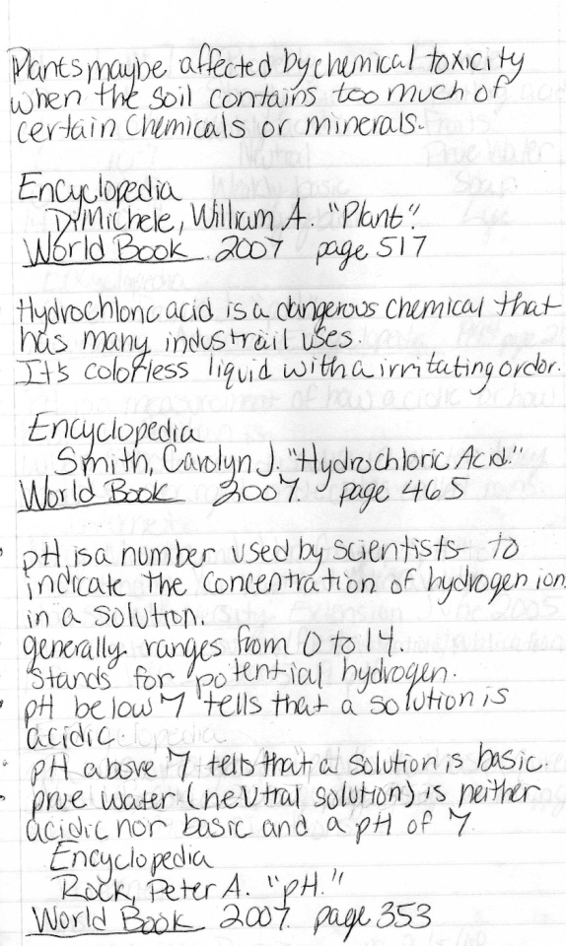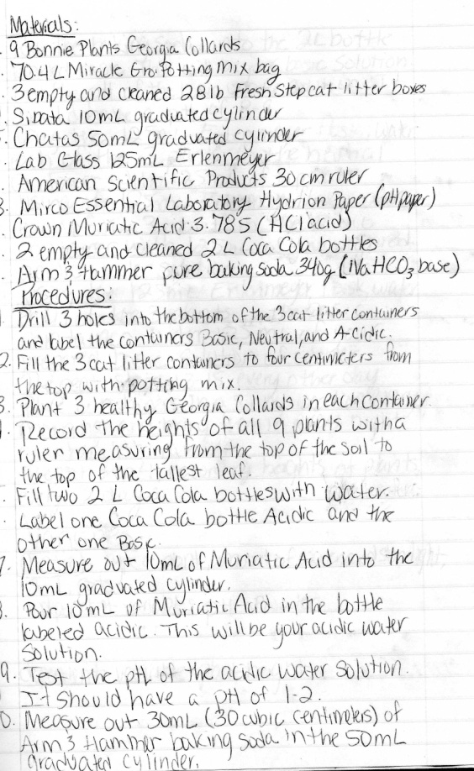
Sample Data Collection Page Sample Results Page with Organized Data
