Checklist: 1. They know the main topic.
2. They can recall three details of a text.
3. They can recognize pictures to understand what the main topic of the text is.

Questions: What is the main topic of the story? What word do I keep reading? Why did you choose this as the main topic of the text?

Checklist: “Do they know what the first number is”? “Do they know what the last number is?” “Do they know the sequence?”
Exit Slip: Connect the Dots: 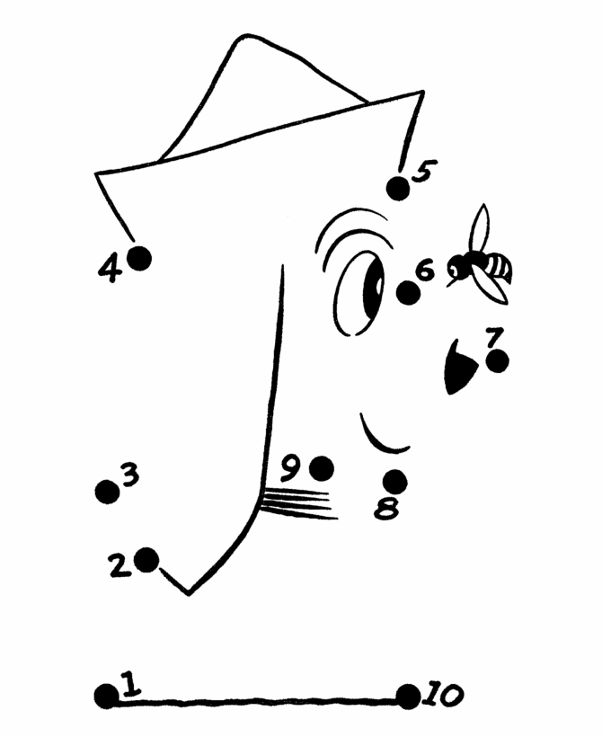
Questions: “What makes this person living”? “How do you know the bed is nonliving”?
Whip Around: (name) “What is one thing you learned today about living and nonliving”?

