Created by Dani Stone 5-23-2016
Location  A particular place of position.  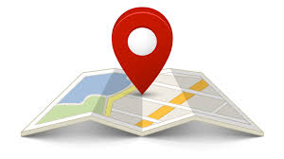 | Distance  The amount of space between two things or two people.  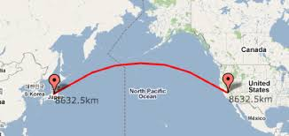
Direction  A course along which something or someone moves.  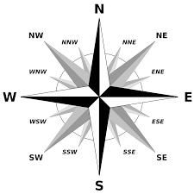 | Community  A group of people living in the same place.  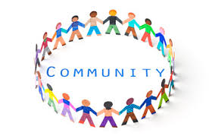

Responsibility  Having a duty to deal with someone or having control over someone.  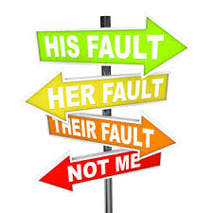 | Citizenship  The status of being a citizen.
Map Scale  An indication of the relationship between the distances on a map, chart, or plan and the corresponding actual distance.  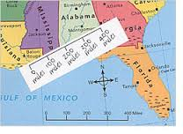 | Compass Rose  A circle of similar design which includes graduated degrees or quarter points, printed on a chart or map for reference.  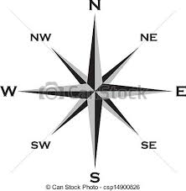

Grid System  A network of horizontal and vertical lines used to locate points on a map or a chart by means of coordinates.  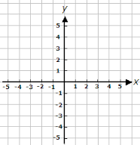 | Physical Environment  Encompasses all nature-made contours to the Earth’s surface such as landforms and geographical regions.  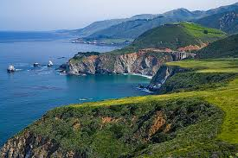
Past  Happened in an earlier time.  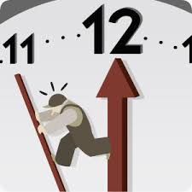 | Present  Now  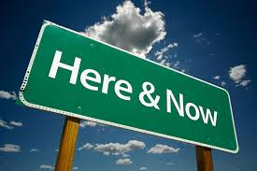

Future  Will happen in a later time.  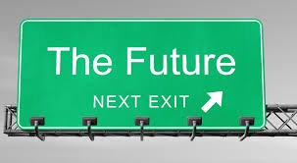 | Year  12 Months  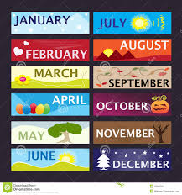
Decade  Ten Years  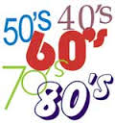 | Century  100 Years  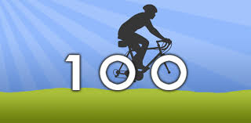

Climate  A pattern of weather at a particular place over a period of years.  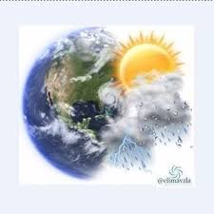 | Landforms  Features of Earth’s surface which include plains, mountains, deserts, hills, and canyons.  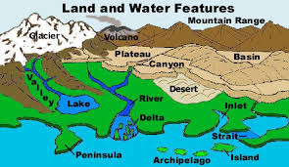
Natural Resources  Any physical material that constitutes part of Earth, and which people need and value.  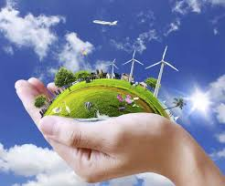 | Natural Hazard  A process or event in the physical environment, not caused by humans and not predictable, but which can destroy human life and property.  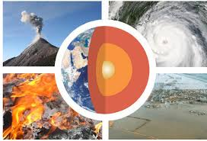

Physical Processes  Changes in landforms, weather, climate, vegetation, and soils.  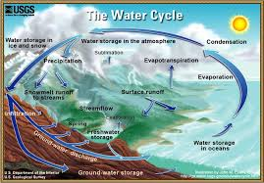 | Landscape  The scenery of a place including the physical characteristics, as well as the human characteristics.  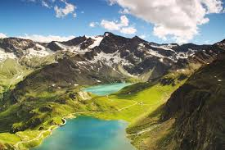
Cardinal Directions  North, South, East, and West  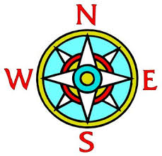 | Intermediate Directions  Mid-way between the cardinal points on a compass. Southwest, Southeast, Northwest, Northeast.  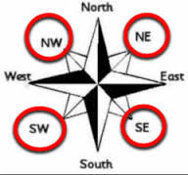

Physical Processes  Changes in landforms, weather, climate, vegetation, and soils. | Landscape  The scenery of a place including the physical characteristics, as well as the human characteristics.
Cardinal Directions  North, South, East, and West | Intermediate Directions  Mid-way between the cardinal points on a compass. Southwest, Southeast, Northwest, Northeast.

Truthfulness  Acting and speaking honestly.  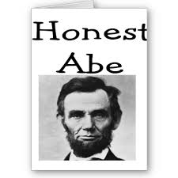 | Justice  The concept of “what is right”, which may be based on many ideas such as following rules and law.  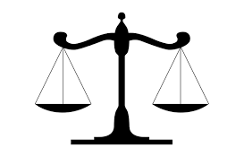
Equality  An equal share for everyone, being fair, treating others equally, and the rules and consequences apply equally to everyone.  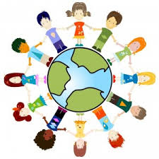 | Respect for Oneself  Caring about personal hygiene, health, well-being.  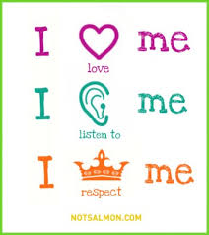

Respect for Others  Acting towards others in a way that an individual would expect to be treated by others.  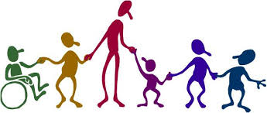 | Responsibility in Daily Life  Being informed, doing good work, living a life of integrity, practicing good stewardship, making good choices.  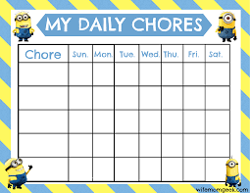
Voting  To anonymously express a preference for a candidate or issue. | Good Citizenship  A person that obeys the laws of their country, contributes to society, and participates in public affairs with wisdom.  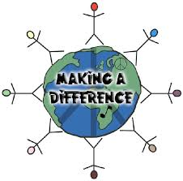

Graphs  A diagram showing the relation between the variable quantities, each measured along one pair of axes at right angle.  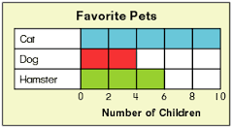 | Charts  A sheet of information in the form of a graph, table, or diagram.  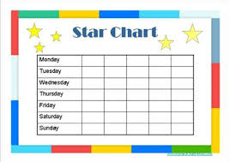
Tables  A set of facts and figures systematically displayed, especially in columns.  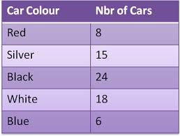 | Illustrations  An example serving to clarify or prove something.  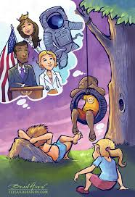

Independence  Freedom from the control, influence, support or aid from others.  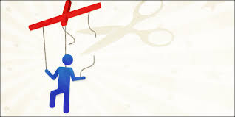 | Leader  The person who commands a group, organization or country.  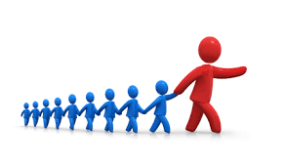
Liberty  Freedom from control by another government.  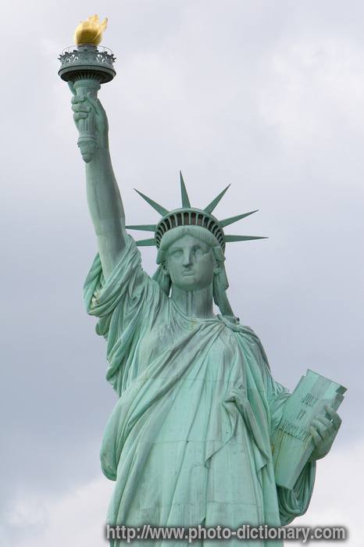 | Freedom  The power to do what you want to do.  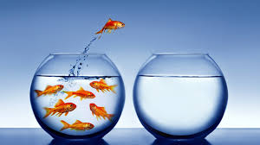

Pursuit of Happiness  A fundamental right mentioned in the Declaration of Independence to freely pursue joy, and live life in a way that makes you happy, as long as you don’t do anything illegal or violate the rights of others.  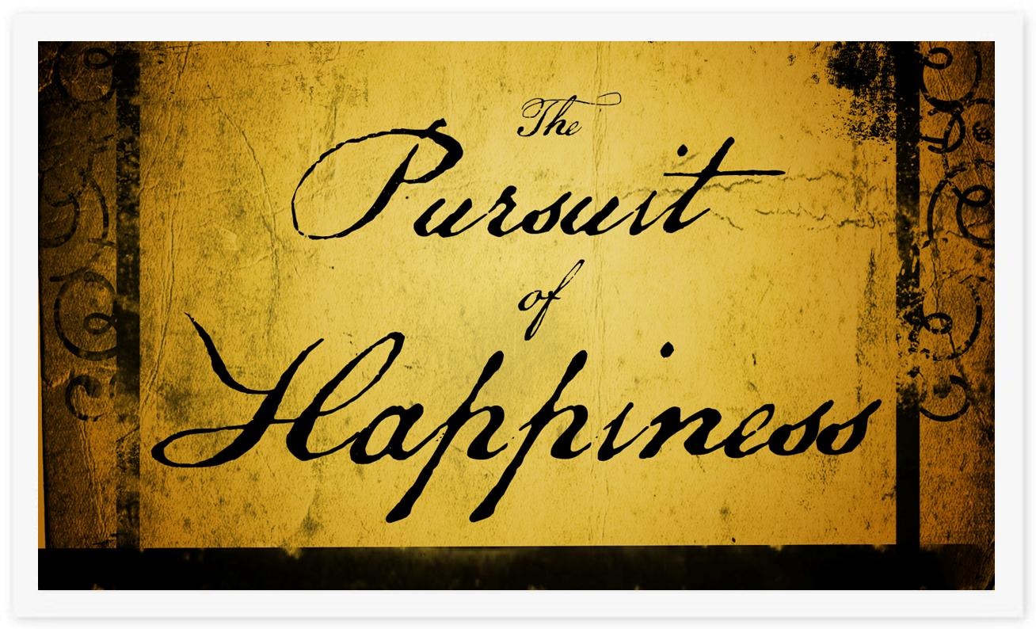 | Constitutional Republic  A state where the officials are elected as representatives of the people, and must govern according to existing constitutional law that limits the government's power over citizens.  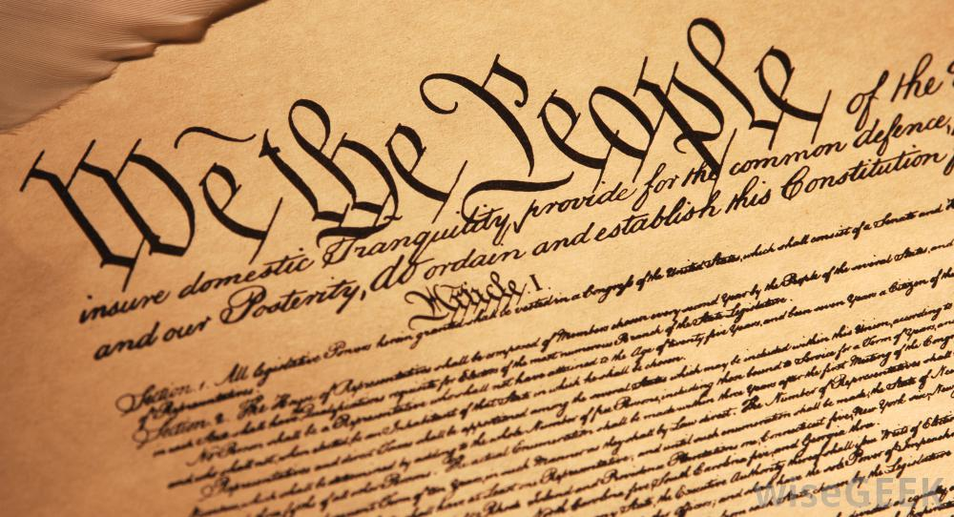
Choice  An act of making decisions when faced with two or more possibilities.  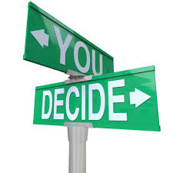 | Consent of the Governed  Government gets all its power from the people.  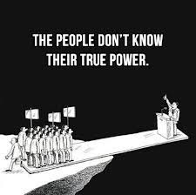

Constitution  One of the foundations of the American system of government is the use of a written constitution defining the values and principles of government and establishing the limits of power.  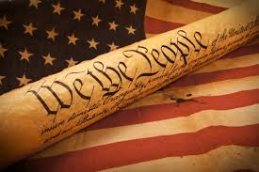 | Bill of Rights  Consists of the first ten amendments to the U.S. Constitution, ratified in 1791. The first protects several fundamental rights of U.S. citizens: freedom of religion, of speech, of the press, to assemble, and to petition.  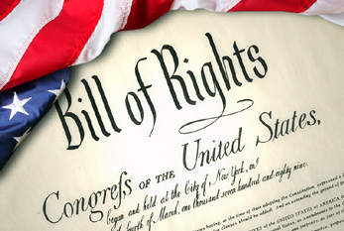
Declaration of Independence  Declares the 13 colonies as independent states, free from rule by Great Britain.  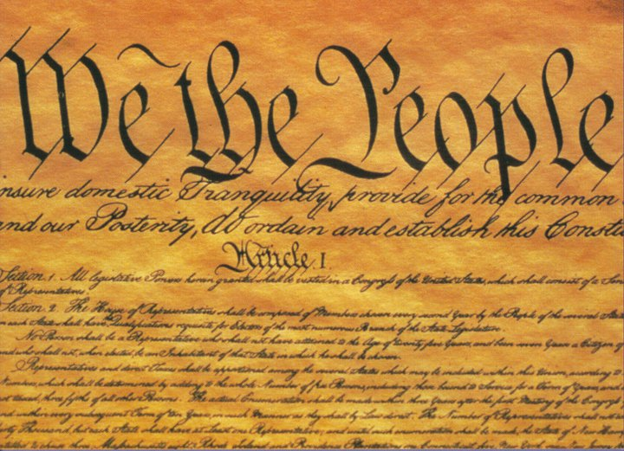 | Founding Fathers  Belief in life, liberty, and the pursuit of happiness made it possible for Americans to settle, form communities, and live freely. Wrote the constitution as a way to guide formation of communities that operate on those principles, then forming and leading our new nation.  