Why don’t I fall out when a roller coaster goes upside down?  Gravity is counteracted by the force of acceleration, which is the force that pushes you forward.  Have you ever wondered how roller coasters stay on their tracks and why people can hang upside down in them? It’s all a matter of physics: energy, inertia, and gravity.  A roller coaster does not have an engine to generate energy. The climb up the first hill is accomplished by a lift or cable that pulls the train up. This builds up a supply of potential energy that will be used to go down the hill as the train is pulled by gravity. Then, all of that stored energy is released as kinetic energy which is what will get the train to go up the next hill. So, as the train travels up and down hills, its motion is constantly shifting between potential and kinetic energy.  The higher the hill the coaster is coming down, the more kinetic energy is available to push the cars up the next hill, and the faster the train will go. Plus, according to Newton’s First Law of Motion, “an object in motion tends to stay in motion, unless another force acts against it.” Wind resistance or the wheels along the track are forces that work to slow down the train. So toward the end of the ride, the hills tend to be lower because the coaster has less energy to get up them.  The two major types of roller coasters are wooden and steel. Features in the wheel design prevent the cars from flipping off the track. Wooden tracks are more inflexible than steel, so usually don’t have such complex loops that might flip passengers upside down. In the 1950s tubular steel tracks were introduced. The train’s nylon or polyurethane wheels run along the top, bottom, and side of the tube, securing the train to the track while it travels through intricate loops and twists.  When you go around a turn, you feel pushed against the outside of the car. This force is centripetal force and helps keep you in your seat.  In the loop-the-loop upside down design, it’s inertia that keeps you in your seat. Inertia is the force that presses your body to the outside of the loop as the train spins around. Although gravity is pulling you toward the earth, at the very top the acceleration force is stronger than gravity and is pulling upwards, thus counteracting gravity. The loop however must be elliptical, rather than a perfect circle, otherwise the centripetal (g) force would be too strong for safety and comfort.  How do we know whether a roller coaster is safe? Engineers and designers follow industry standards and guidelines. The first “riders” are sandbags or dummies. Then engineers and park workers get to try it out. Would you want to be one of the first passengers on a new ride?  - Fun facts:  The ancestor of the roller coaster is traced to Russia in the 15th century, a gravity sled ride called Russian Mountains.  - One of the first roller coasters was in France in 1817 - Les Montagnes Russes à Belleville (Russian Mountains of Belleville) - the train axle was attached to the track by way of a carved groove.  - In 1827, the Mauch Chunk Switchback Railroad, (Summit Hill, PA) built a track 18 miles down a mountain to transport coal. In 1873, it became a scenic, albeit bumpy, pleasure ride. It remained in operation until 1938.  - La Marcus Thompson built the Switchback Railway at Coney Island, Brooklyn, NY, in 1884. He has been called the “father of gravity” and holds several patents including US Patent 310,966 (1885) for “Roller coaster structure,” and US Patent 1,102,821 (1914) for “Signaling device for racing coasters.”  - One of the first high-speed coasters was Drop-The-Dip, at Coney Island, Brooklyn, NY (1907). At this time lap restraints started to be used.  - The first tubular steel coaster was the Matterhorn Bobsledsat Disneyland, Anaheim, CA (1959).  - Knott's Berry Farm, Buena Park, CA, introduced the Corkscrew (1975), the first coaster to completely invert passengers.  - King Cobra, Kings Island, Cincinnati, OH (1984) was the first roller coaster that allowed people to stand up.  - The longest roller coaster at this time is Steel Dragon 2000, Nagashima Spa Land, Japan, at 8,133 feet/2,479 m.  - As of 2005, the tallest steel continuous circuit roller roaster is Kingda Ka at Six Flags Great Adventure, Jackson Township, NJ, 139m/456 feet. It is also the fastest at 128 mph/206 km/h. A ride lasts 50.6 seconds. | 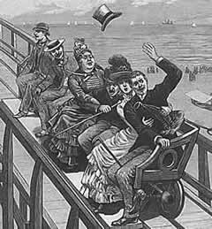  "Hold on to your hat!" Prints & Photographs Division, Library of Congress (scanned from print.)  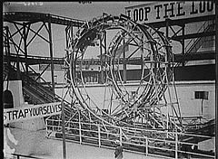  Loop the loop, Luna Park, Coney Island [between 1903 and 1910]  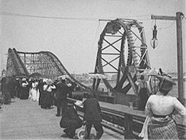  Looping the loop, Atlantic City, 1901. Prints & Photographs Division, Library of Congress.  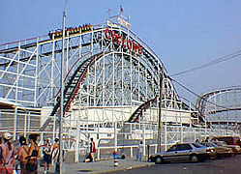  "The Cyclone at Coney Island has been terrorizing riders since the late 1920s." Photo from the USGS Field Trips to the Shore Web page.  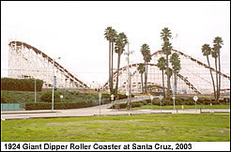  The Giant Dipper, a National Historic Landmark, at Santa Cruz, CA. Photo from the National Park Service Web site.  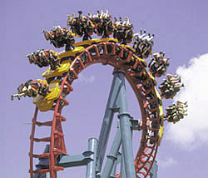  Serial Thriller, is just one of the many roller coasters that add a twist to physics lessons. Credit: Geauga Lake & Wildwater Kingdom. From the NASA Life on Earth website.

This article is in the public domain and can be retrieved at the following link:
https://www.loc.gov/rr/scitech/mysteries/rollercoaster.html

