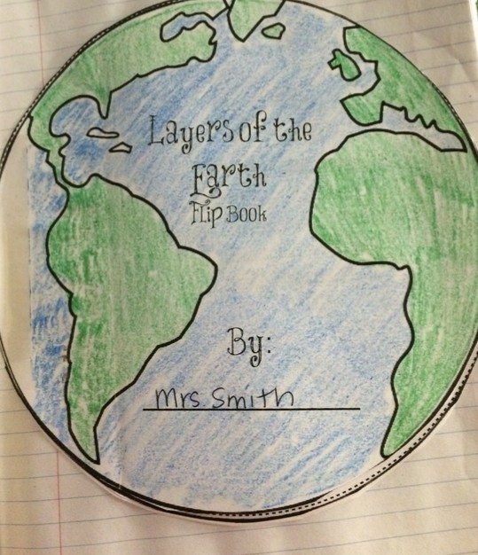

Layers of the Earth
Flip Book
Perfect for Interactive Notebooks!

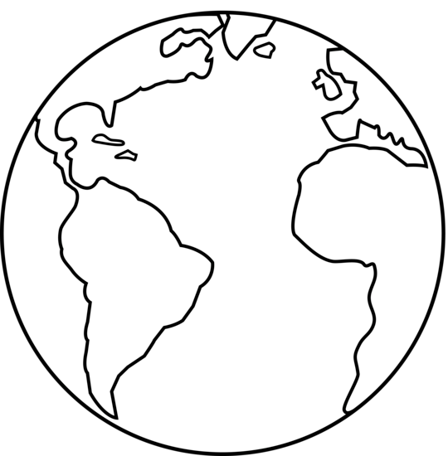

Layers of the Earth
Flip Book

By:

Instructions: Draw the thin crust, color it GREEN & write the thickness, temperature, state of matter and composition of the crust on the lines. Cut out the circle, use glue on the ‘glue’ side & attach it to the back of the title circle.

Crust
Glue

Instructions: Draw the crust, color it GREEN, then draw the mantle & color it brown. Write the thickness, temperature, state of matter and composition of the mantle on the lines. Cut out the circle, use glue on the ‘glue’ side & attach it to the back of the crust circle.

Mantle
Glue

Instructions: Draw the crust, color it GREEN, then draw the mantle & color it brown, and now draw the outer core & color it ORANGE. Write the thickness, temperature, state of matter and composition of the outer core on the lines.
Cut out the circle, use glue on the ‘glue’ side & attach it to the back of
the mantle circle.

Outer Core
Glue

Instructions: Draw the crust, color it GREEN, then draw the mantle & color it brown, draw the outer core & color it ORANGE, and finally draw the inner core and color it RED. Write the thickness, temperature, state of matter and composition of inner core on the lines. Cut out the circle, use glue on the ‘glue’ side & attach it to the back of
The outer core circle.

Inner Core
Glue

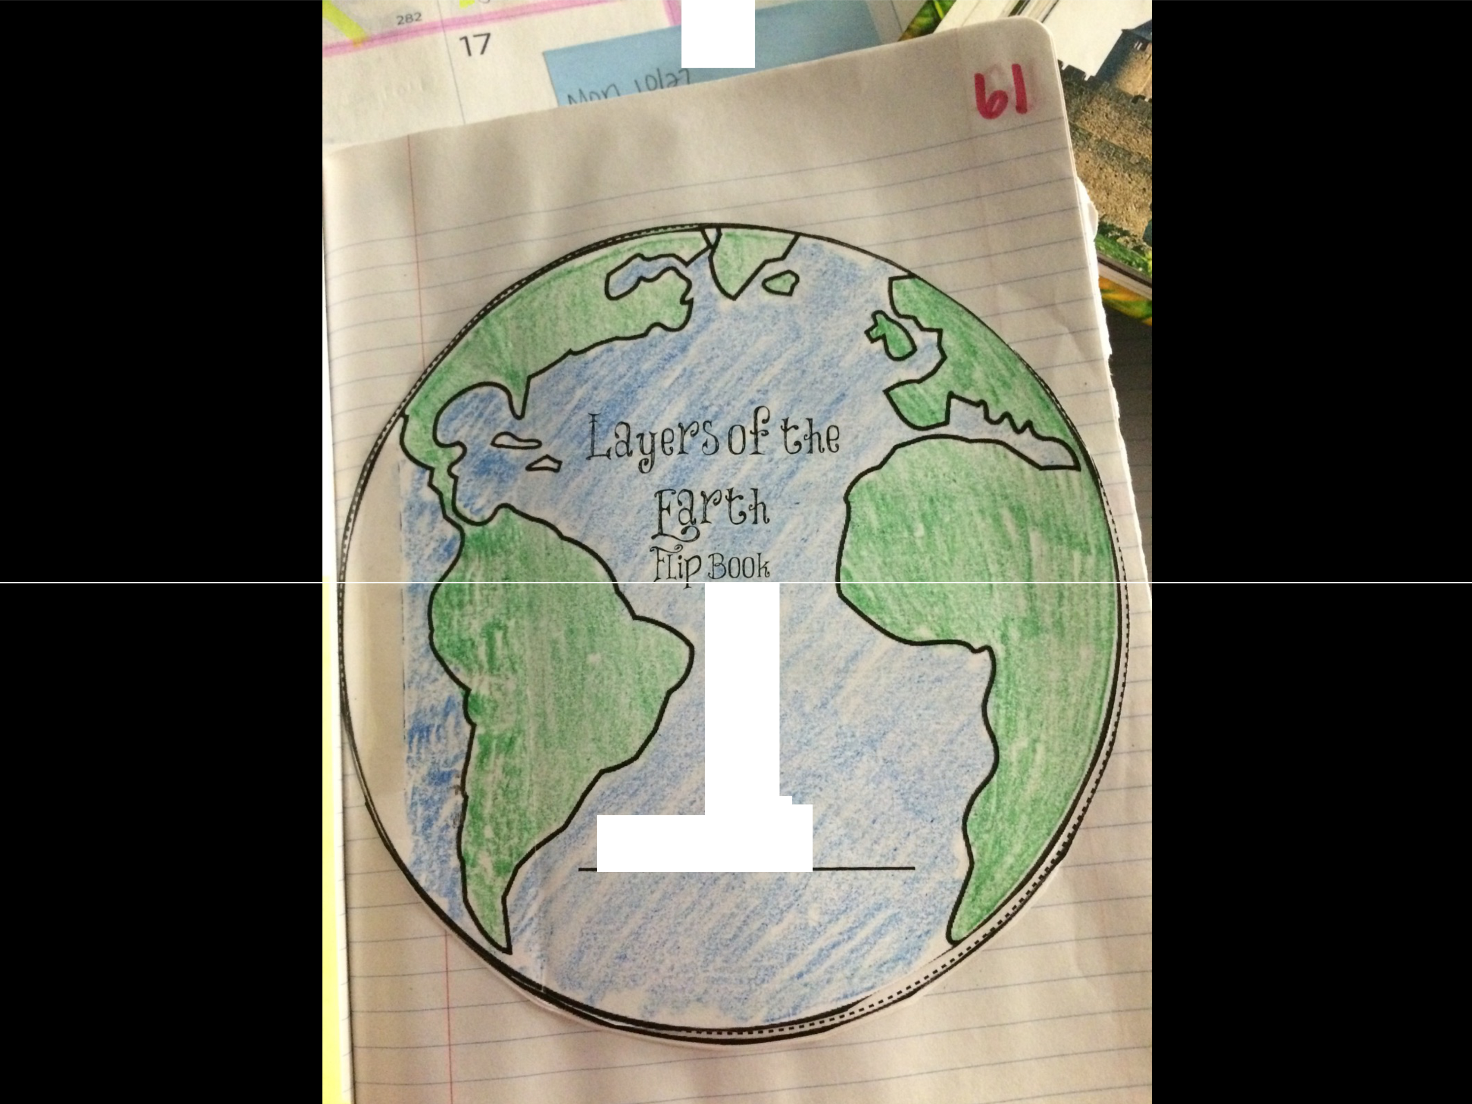,. JI ----

By: .
my:c; . sm\ -th

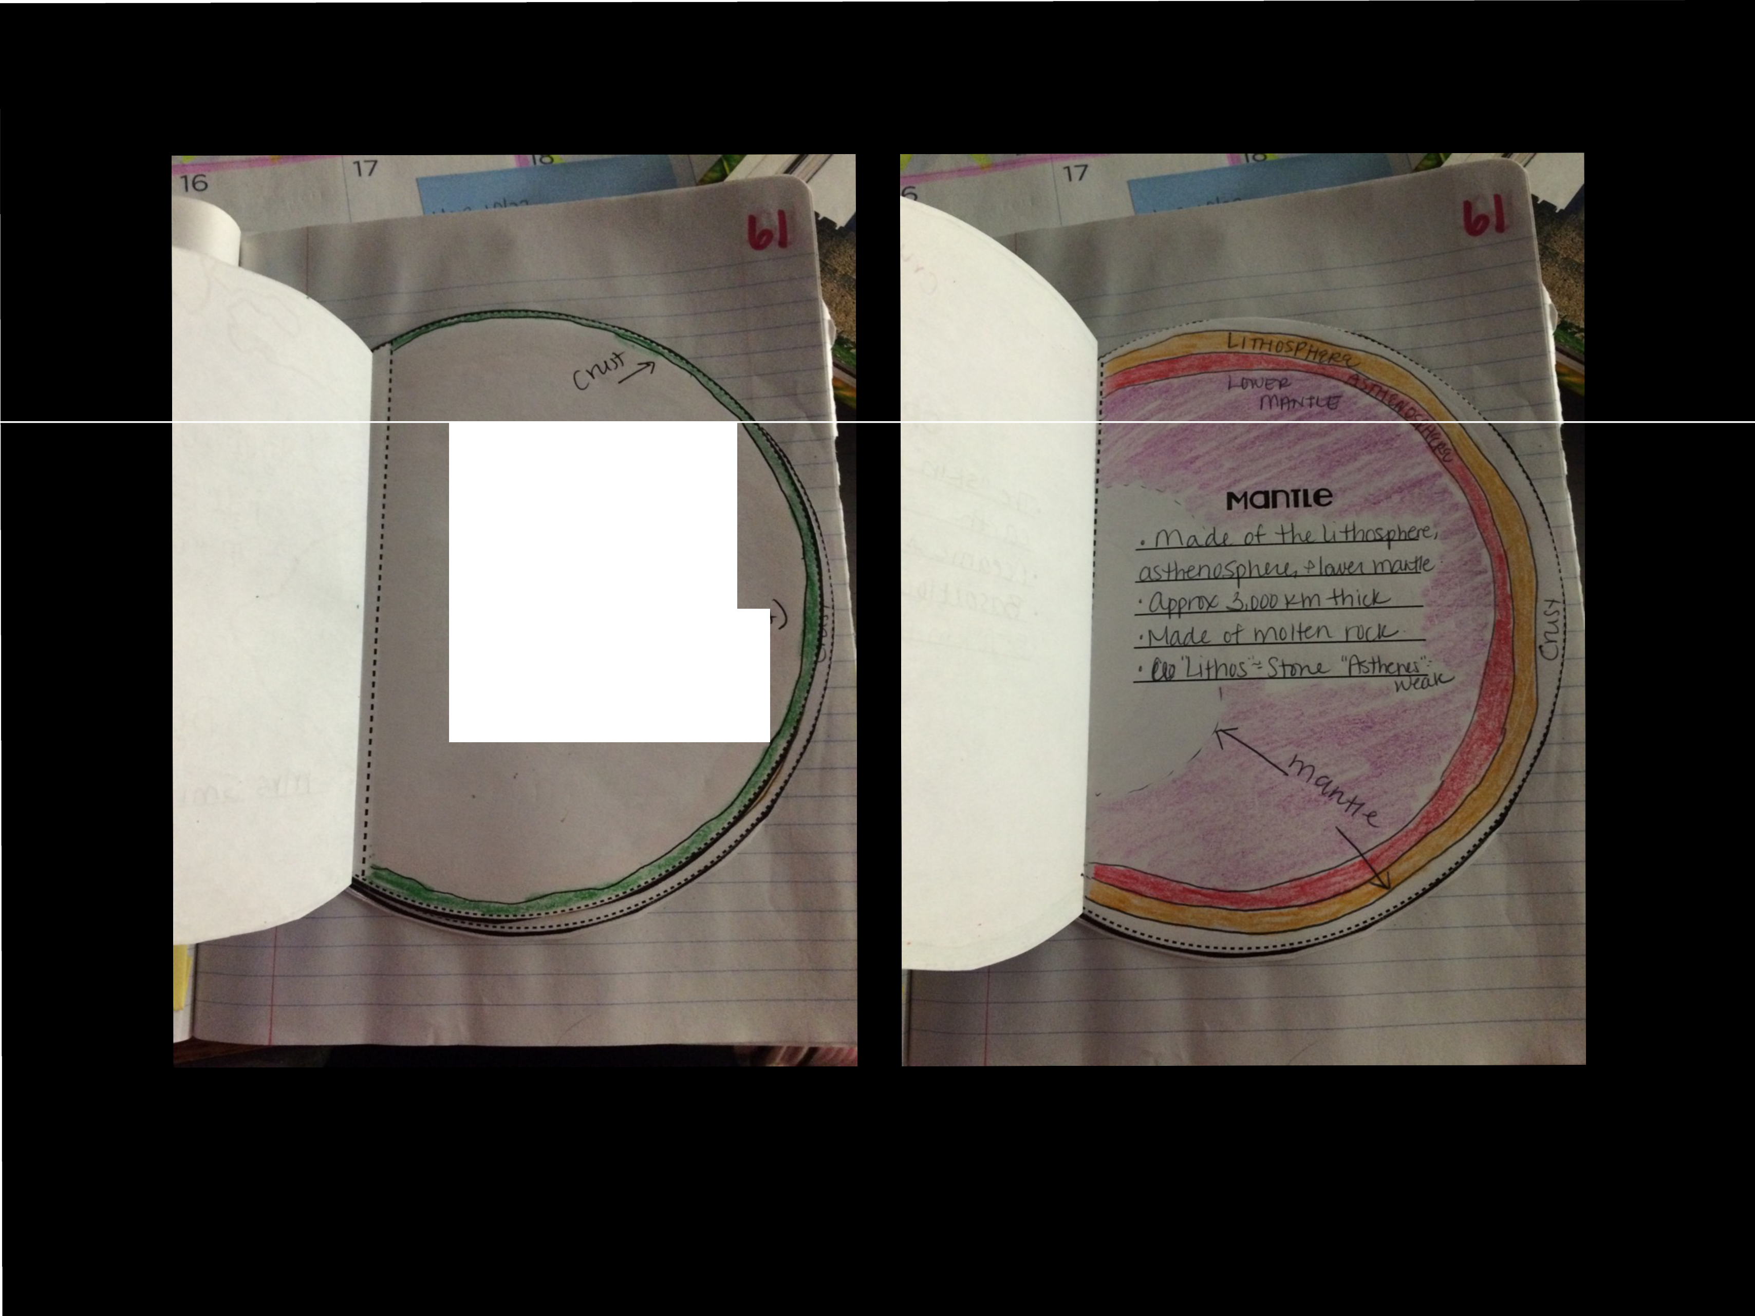

CRUil
•::Il:Cc ''s"='np of ::t:l:v.
W.r±b: ·
- De ca n iee + CAot:i aeo+,,.,,,
·fusa,t(ouo..) grao1k
'5-10 ILto:tb,c.ke

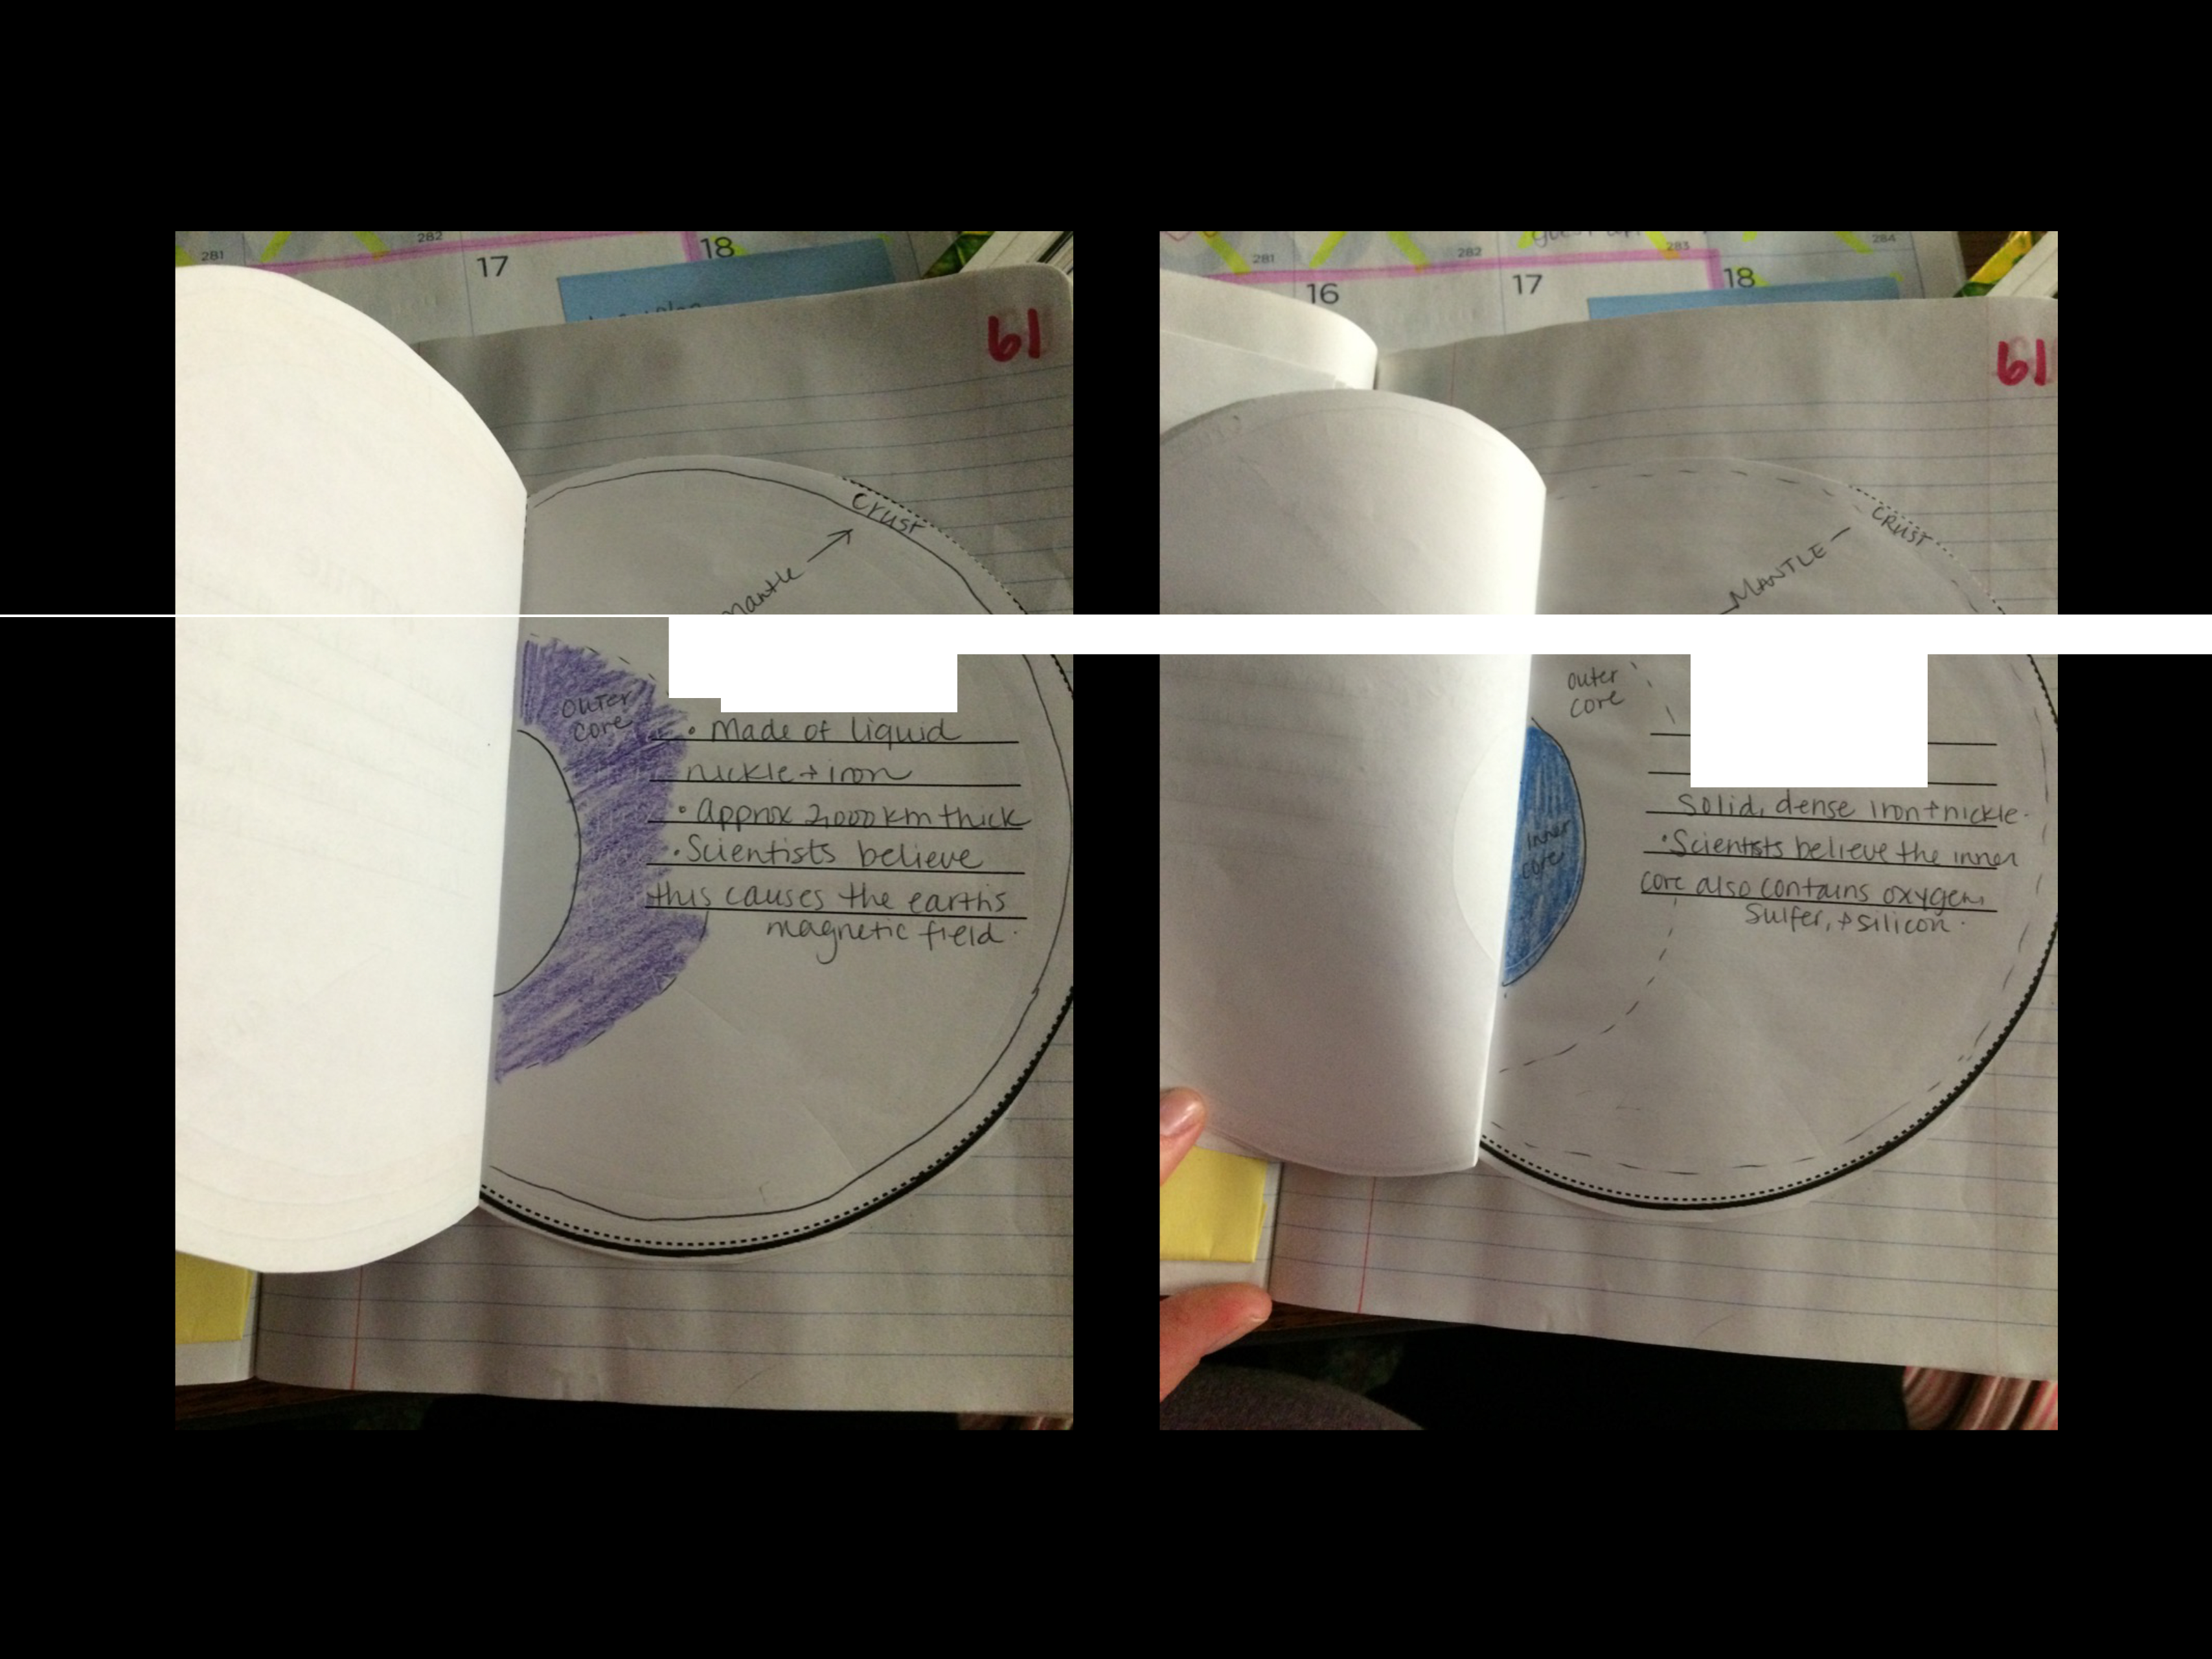

OUTeR CORe INNCR CORC
.a<2P(ff)( }IQpo
·h'\a d , of

Teacher Guide

This flip book would be a great addition glued into an interactive notebook! The students should use arrows to point to each layer on each page.
You can have your students research 2 facts about each Earth layer OR you can give them the facts. Here are a few you could use:

Crust: There are 2 types of crust (continental & oceanic), Oceanic crust is thinner than continental crust, The crust is anywhere between 3-50 miles thick.

Nantle: The mantle is broken down into the lithosphere, asthenosphere, & lower mantle. The mantle is composed of hot, solid rock.

Outer Core: The outer core is made of liquid iron & nickel. Convection currents in the outer core are thought to cause the Earth’s magnetic field.

Inner Core: The inner core is a dense, solid ball of metal (iron & nickel).

