Aztec & Mayan Civilization Vocabulary
Create the Vocabulary squares for the following words:
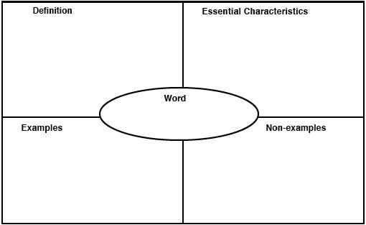
- Tribute- a gift to show gratitude or respect for security or protection. (Aztecs required places they conquered to pay them tribute)
- Chinampas-floating gardens used to grow food
- Glyph-a symbol or figure representing a sound or object
- City-state- an area with its own government and systems in place
- Sacrifice- an act of slaughtering an animal or person or surrendering a possession as an offering to a god or a supreme being
- Slash and burn agriculture- a method for growing crops in which all vegetation is cut down and then burned. In new blank space you will plant the crops you do want growing.
- Causeway- a raised road across low or flat land
- Aqueduct- an artificial channel for moving water from place to place
- Dike- a long wall or embankment built to prevent flooding
- Maize- the technical term for corn
- Meso America- the area of North America that includes Central America, Mexico, and all the countries in between North and south America

