You are going to create squares for your vocabulary the words should be at the center then a sentence, picture, synonym/antonym, definition for the squares. Each square should be at least half a notebook page in your interactive notebook. Please complete a square for each of the following words:
- Archaic People- existed after the Paleo Indians after the ice age ended and the world began to warm up from 8,000-2000 B.C.
- Desert Archaic People- the people of the southwest during this time period whom had to live with a desert climate
- Culture- Beliefs, customs, arts and ways of life of a group of people
- Atlatl- A spear throwing device 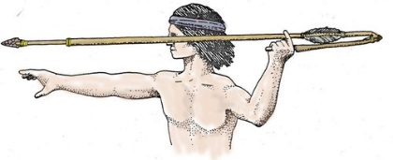
- Pithouse- a type of shelter partly dug into the earth and roofed over in a doom shape with branches, twigs, and dirt
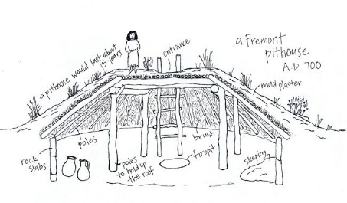
- Agriculture- the science of farming; cultivation of soil, growing of crops, etc.
- Mano- grinding tool used to grind corn into flour, a stone that fits in the palm of your hand
- Metate- grinding tool used to grind corn into flour a flat stone
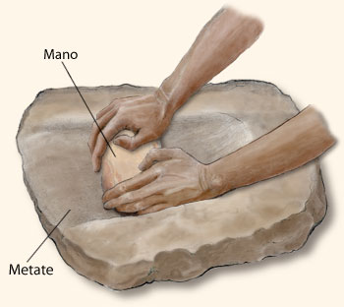
- Domesticate-tame an animal and keep as a pet

