**FILIBUSTER**: When a Senator wastes time by talking for hours to “run out the clock” thereby preventing a vote on a bill that he does not like.

(Throw this card down on an opponent’s LEGISLATION to block his next move – *he loses TWO turns or starts Legislation over*)

PARTY WHIP

You have been chosen as your Party’s WHIP

In the Senate

**+ 10% POINTS Party Support**

**Bill is stuck in committee.** Throw this card down next to an opponents LEGISLATION Path if his bill is in either Committee or Sub-Committee to block his next move – *he loses TWO turns or starts Legislation over*) when done place this card on the discard pile.

**Bill dies in committee .**

Throw this card down next to an opponents LEGISLATION Path if his bill is in either Committee or Sub-Committee to block his next move – *he must pick a new LEGISLATION card on his next turn AND moves back to start*

***Your* Bill is stuck in committee.**

If ***YOU*** have a bill in either Committee or Sub-Committee you *lose TWO turns or start your Legislation over by choosing a new Legislation card)*

***Your* state has an emergency!**

But you are slow to react! Your popularity drops 10 percentage points

**PRESIDENT PRO TEMP**

You have been elected **PRESIDENT PRO TEMP** of the Senate

**+ 20% POINTS Party Support**

**WHITE HOUSE RUN?**

There is talk of you being a candidate for President.

**+ 10% POINTS Party Support**

**HEAD COMMITTEE**

You have been chosen to head an important committee.

**+ 10% POINTS Party Support**

**PARTY LEADER**

You have been elected your Party’s Leader In the Senate

**+ 20% POINTS Party Support**

PARTY WHIP

You have been chosen as your Party’s WHIP in the Senate

**+ 10% POINTS Party Support**

**LOBBY**

YOU ARE ABLE TO SIPHON AWAY $ FROM AN IMPORTANT LOBBYING GROUP

Put this card down on any other player. They lose $100 K **AND** **YOU GAIN $100 K**

**LOBBY**

YOU ARE ABLE TO SIPHON AWAY $ FROM AN IMPORTANT LOBBYING GROUP

Put this card down on any other player. They lose $100 K **AND** **YOU GAIN $100 K**

**PARTY LEADER**

You have been elected your Party’s LEADER

In the Senate

**+ 20% POINTS Party Support**

**YOU ARE APPOINTED TO AN IMPORTANT COMMITTEE !** Your PARTY SUPPORT goes up 10 percentage points!

***Your* Bill dies in committee**

If ***YOU*** have a bill in either Committee or Sub-Committee, ***YOU*** must move back to the ***first space*** on your LEGISLATION PATH *and pick a new card from the Legislation deck* ***during your next turn****.*

**CLOTURE:** A majority vote of 2/3 of the Senate that overcomes a Filibuster. (Use this card *to overcome* a FILIBUSTER that is blocking your path. – *You DO NOT lose two turns and you DO NOT start Legislation over)*

**A fellow Senator objects to your Bill’s proposal.**

Throw this card down next to an opponents LEGISLATION Path if his bill is on spaces 1 to 3 on the PATH. *He moves back to start AND must pick a new LEGISLATION CARD on his next turn.*

**ACTION**

**ACTION**

**ACTION**

**ACTION**

**ACTION**

**ACTION**

**ACTION**

**ACTION**

**ACTION**

**ACTION**

**ACTION**

**ACTION**

**ACTION**

**ACTION**

**ACTION**

**ACTION**

**ACTION**

**ACTION**

**Lobby Support: Subsidizing Big Fossil Fuel Companies**

If Republican: If Democrat:

+ $50K to - 5% points

your War Chest in Popularity

**You are against discrimination based on sexual orientation.**

If Republican: If Democrat:

- 5% points in + 5% points in

Party Support Party Support

**Support from Gun Control Special Interest Group**

If Republican: If Democrat:

- 5% points + $50K to

in Popularity your War Chest + $50K to - 5% points

your War Chest in Popularity

**Support from Religious Right anti-Same-Sex Marriage**

If Republican: If Democrat:

+ 5% to points - 5% points

to Popularity in Popularity

**Insurance Lobby donates to your Campaign**

If Republican: If Democrat:

+ $50K to - 5% points

your War Chest in Popularity

**Big push for Increasing Tax on the Wealthy**

If Republican: If Democrat:

- 5% points + 5% to points

in Popularity in Popularity

**You support the Deregulation of big banks and Wall Street**

If Republican: If Democrat:

+ 5% points in - 5% points in

Party Support Party Support

**You support vouchers for school choice**

If Republican: If Democrat:

+ 5% points in - 5% points in

Party Support Party Support

**You support Strong Law Enforcement**

If Republican: If Democrat:

+ 5% points in - 5% points in

Party Support Party Support

**You support subsidizing Big Fossil Fuel Companies**

If Republican: If Democrat:

+ 5% points in - 5% points in

Party Support Party Support

THE HOUSE BILL IS DIFFERENT THAN THE SENATE BILL. A JOINT COMMITTEE MUST BE FORMED. This holds any further advance on your bill for two turns

**The President vetoes your bill. You cannot advance for two turns**

***Your* state has an emergency!**

You fast reaction impresses your constituency. Your Constituent Popularity rises 10 percentage points

**Military Industrial Complex Likes Expanding the Military**

If Republican: If Democrat:

+ $50K to - 5% points

your War Chest in Popularity

**Lobby Support: Renewable Energy Programs**

If Republican: If Democrat:

- 5% points + 5% to points

in Popularity in Popularity

**Dinner given by Pro-Choice Special Interest Group**

If Republican: If Democrat:

- 5% points + $50K to

in Popularity your War Chest

**Voucher for school choice grows in popularity**

If Republican: If Democrat:

+ 5% to points - 5% points

to Popularity in Popularity

**Lobby support for Expanding the size of the Military**

If Republican: If Democrat:

+ $50K to - 5% points

your War Chest in Popularity

**ACTION**

**ACTION**

**ACTION**

**ACTION**

**ACTION**

**ACTION**

**ACTION**

**ACTION**

**ACTION**

**ACTION**

**ACTION**

**ACTION**

**ACTION**

**ACTION**

**ACTION**

**ACTION**

**ACTION**

**ACTION**

**LOSING $ SUPPORT**

A tough economy is affecting your campaign donations

- $100K $ CAMPAIGN WAR CHEST $

**POPULARITY FALLING**

Let’s face it… your really boring!

- 10% POINTS Constituent Popularity

**You give a pro-environment speech.**

If Republican: If Democrat:

- 5% points in +5% points in

Party Support Party Support

**You give a pro-Gun Control speech.**

If Republican: If Democrat:

- 5% points in +5% points in

Party Support Party Support

**You give a speech against Banking Regulations**

If Republican: If Democrat:

+5% points in -5% points in

Party Support Party Support

**You give a speech against Government run Universal Health Care**

If Republican: If Democrat:

+5% points in -5% points in

Party Support Party Support

**You give a Pro-Choice** **speech.**

If Republican: If Democrat:

- 5% points in +5% points in

Party Support Party Support

**You give a speech against Increasing Tax on the Wealthy**

If Republican: If Democrat:

+5% points in -5% points in

Party Support Party Support

**You give a Pro-Life** **speech**

If Republican: If Democrat:

+5% points in -5% points in

Party Support Party Support

**Your bill is changed by the House; a Conference Committee is called.**

If your bill is at space #7 or less, lose one turn

**Your bill is changed by the House; a Conference Committee is called.**

if your If your bill is at space #7 or lower go back to START. Next turn pick another LEGISLATION CARD from the deck. Continue this until you get a bill your Party likes. If your bill is passed this point, discard and take no action

**You give a speech against Renewable Energy**

If Republican: If Democrat:

+5% points in -5% points in

Party Support Party Support

**You give a Pro-Civil Rights speech.**

If Republican: If Democrat:

- 5% points in +5% points in

Party Support Party Support

**You give a pro-Refinancing student loans speech.**

If Republican: If Democrat:

- 5% points in +5% points in

Party Support Party Support

**LOSING PARTY SUPPORT**

A young intern claims to be the victim of improper advances.

-10% POINTS Party Support

**SPECIAL INTEREST GROUP**

The World Wildlife Federation sees a You Tube video of you play wrestling with a large Panda.

+$50K $ CAMPAIGN WAR CHEST $

**SPECIAL INTEREST GROUP**

You become known for bicycling everyday from your home to the Capitol building.

+$50K $ CAMPAIGN WAR CHEST $

DINNER FOR CONTRIBUTIONS

A $500 a plate dinner brings in a nice amount of change.

+$50K $ CAMPAIGN WAR CHEST $

**ACTION**

**ACTION**

**ACTION**

**ACTION**

**ACTION**

**ACTION**

**ACTION**

**ACTION**

**ACTION**

**ACTION**

**ACTION**

**ACTION**

**ACTION**

**ACTION**

**ACTION**

**ACTION**

**ACTION**

**ACTION**

***“Reach across the isle”*** Put this card down on opponent’s LEGISLATION PATH **if they are of the opposing party.** They move ahead 2 spaces. You also move ahead 2 spaces, but at the cost of a drop of 10 percentage points in PARTY SUPPORT.

***CAUSE TROUBLE!*** If another Senator’s Legislation is something that your constituency is against, put this card down on that player. This halts their legislation for two turns & increases your Constituent Popularity by 10 percentage points

***CAUSE TROUBLE!*** If another Senator’s Legislation is something that your constituency is against, put this card down on that player. This halts their legislation for two turns & increases your Constituent Popularity by 10 percentage points,

***A member of your staff has been sharing sensitive information*** with the opposing party. Your

**$ CAMPAIGN WAR CHEST $** drops by $100,000. All other players’ PARTY SUPPORT goes up 10 percentage points.

Another member of your party has decided to run for your Senate seat.

- $100K $ CAMPAIGN WAR CHEST $

OR

- 10% POINTS Constituent Popularity

OR

-10% POINTS Party Support

***DIRT!*** Your staff finds embarrassing information about one of your fellow Senators. Put this down on any other player and tell them to make one subtraction below ***YOUR CHOICE.***

$100K $ CAMPAIGN WAR CHEST$

- 10% POINTS Constituent Popularity

-10% POINTS Party Support

Another member of your party has decided to run for your Senate seat.

- $100K $ CAMPAIGN WAR CHEST $

OR

- 10% POINTS Constituent Popularity

OR

-10% POINTS Party Support

You give a speech supporting another player’s opponent.

Put this card down on any other player to cost them - 10% POINTS in Constituent Popularity

**Objections to your new bill.** If your bill is at space #3 or less, go back to START and on your next turn pick another LEGISLATION CARD from the deck. Do this for each turn until you get a bill approved by your own party. If your bill is passed this point, discard and take no action

**The standing committee refuses to refer your Bill to the subcommittee.** If your bill is at space #4 or lower go back to START and on your next turn pick another LEGISLATION CARD from the deck. Do this for each turn until you get a bill If your bill is passed this point, discard and take no action

**Your bill “dies in committee”** if your If your bill is at space #5 or lower go back to the beginning and on your next turn pick another LEGISLATION CARD from the deck. Do this for each turn until you get a bill. If your bill is passed this point, discard and take no action

***Your* state has an emergency!**

And your “take-charge” attitude saves the day!

CONSTITUENT POP. +10% POINTS

AND

PARTY SUPPORT +10% POINTS

Another member of your party has decided to run for your Senate seat.

- $100K $ CAMPAIGN WAR CHEST $

OR

- 10% POINTS Constituent Popularity

OR

-10% POINTS Party Support

***A member of your staff has been sharing sensitive information*** with the opposing party. Your

**$ CAMPAIGN WAR CHEST $** drops by $100,000. All other players’ PARTY SUPPORT goes up 10 percentage points.

***CAUSE TROUBLE!*** If another Senator’s Legislation is something that your constituency is against, put this card down on that player. This halts their legislation for two turns & increases your Constituent Popularity by 10 percentage points

***“Reach across the isle”*** Put this card down on opponent’s LEGISLATION PATH **if they are of the opposing party.** They move ahead 2 spaces. You also move ahead 2 spaces, but at the cost of a drop of 10 percentage points in PARTY SUPPORT.

***“Reach across the isle”*** Put this card down on opponent’s LEGISLATION PATH **if they are of the opposing party.** They move ahead 2 spaces. You also move ahead 2 spaces, but at the cost of a drop of 10 percentage points in PARTY SUPPORT.

***“Reach across the isle”*** Put this card down on opponent’s LEGISLATION PATH **if they are of the opposing party.** They move ahead 2 spaces. You also move ahead 2 spaces, but at the cost of a drop of 10 percentage points in PARTY SUPPORT.

**ACTION**

**ACTION**

**ACTION**

**ACTION**

**ACTION**

**ACTION**

**ACTION**

**ACTION**

**ACTION**

**ACTION**

**ACTION**

**ACTION**

**ACTION**

**ACTION**

**ACTION**

**ACTION**

**ACTION**

**ACTION**

**Your Legislation proceeds on track.**

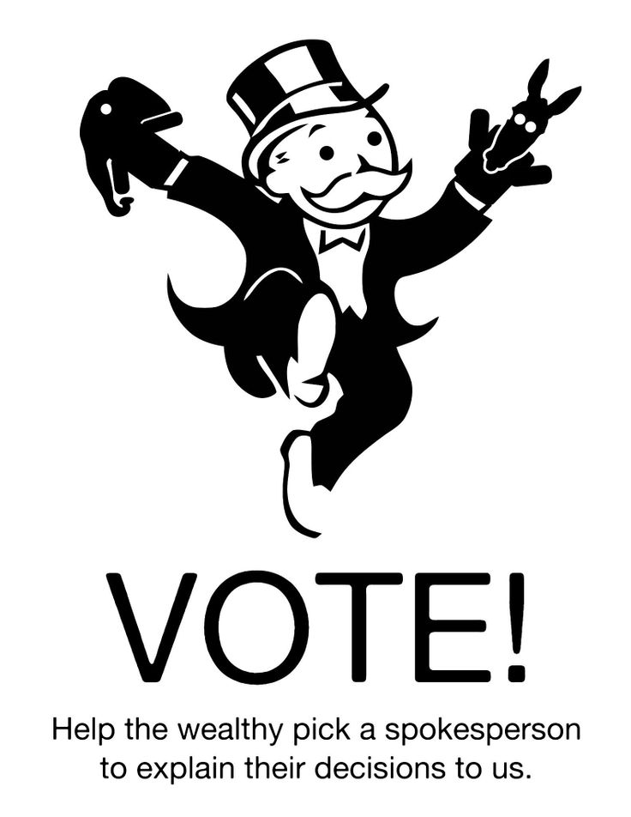**Move your bill on to the next space on your Legislation Path. Then return this card to the bottom of the deck**

**Your Legislation proceeds on track.**

**Move your bill on to the next space on your Legislation Path. Then return this card to the bottom of the deck**

**Your Legislation proceeds on track.**

**Move your bill on to the next space on your Legislation Path. Then return this card to the bottom of the deck**

**Your Legislation proceeds on track.**

**Move your bill on to the next space on your Legislation Path. Then return this card to the bottom of the deck**

**Your Legislation proceeds on track.**

**Move your bill on to the next space on your Legislation Path. Then return this card to the bottom of the deck**

**Your Legislation proceeds on track.**

**Move your bill on to the next space on your Legislation Path. Then return this card to the bottom of the deck**

**Your Legislation proceeds on track.**

**Move your bill on to the next space on your Legislation Path. Then return this card to the bottom of the deck**

**Your Legislation proceeds on track.**

**Move your bill on to the next space on your Legislation Path. Then return this card to the bottom of the deck**

**Your Legislation proceeds on track.**

**Move your bill on to the next space on your Legislation Path. Then return this card to the bottom of the deck**

**Your Legislation proceeds on track.**

**Move your bill on to the next space on your Legislation Path. Then return this card to the bottom of the deck**

**Your Legislation proceeds on track.**

**Move your bill on to the next space on your Legislation Path. Then return this card to the bottom of the deck**

**Your Legislation proceeds on track.**

**Move your bill on to the next space on your Legislation Path. Then return this card to the bottom of the deck**

**Your Legislation proceeds on track.**

**Move your bill on to the next space on your Legislation Path. Then return this card to the bottom of the deck**

**Your Legislation proceeds on track.**

**Move your bill on to the next space on your Legislation Path. Then return this card to the bottom of the deck**

**Your Legislation proceeds on track.**

**Move your bill on to the next space on your Legislation Path. Then return this card to the bottom of the deck**

**Your Legislation proceeds on track.**

**Move your bill on to the next space on your Legislation Path. Then return this card to the bottom of the deck**

**Your Legislation proceeds on track.**

**Move your bill on to the next space on your Legislation Path. Then return this card to the bottom of the deck**

**Your Legislation proceeds on track.**

**Move your bill on to the next space on your Legislation Path. Then return this card to the bottom of the deck**

**ACTION**

**ACTION**

**ACTION**

**ACTION**

**ACTION**

**ACTION**

**ACTION**

**ACTION**

**ACTION**

**ACTION**

**ACTION**

**ACTION**

**ACTION**

**ACTION**

**ACTION**

**ACTION**

**ACTION**

**ACTION**