________________________________________________________________________________

**Based on the Reasons for Settlement, as Stated in the Charter of 1732, Was the Georgia Colony a Success or Failure?**

________________________________________________________________________________

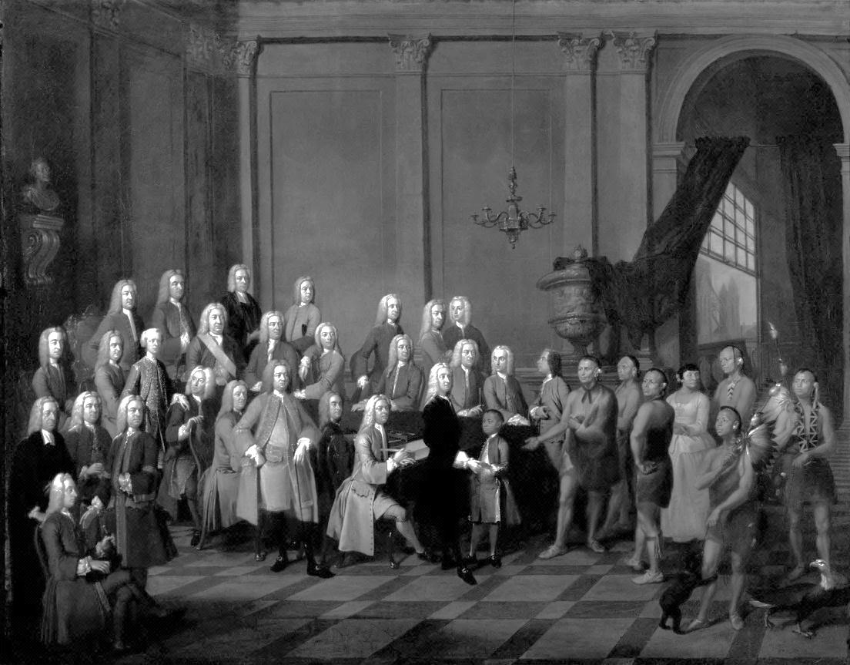

**Overview:**

On February 12, 1733, approximately 120 English colonists arrived at Yamacraw Bluff (present-day Savannah, Georgia). Under the guidance of a group of Trustees, and led by Sir James Oglethorpe (a Trustee himself), the new settlers were to establish His Royal Majesty King George II’s thirteenth English colony which would be called Georgia. The charter granted by the King required the new colony to provide charity to England’s poor by offering a chance to start anew, provide defense by acting as a buffer between the profitable Carolina colony and any direct threats, and to benefit England economically through the natural resources and raw materials that would be sent back to the mother country. This Mini-Q asks whether the Georgia colony succeeded or failed in fulfilling the charter requirements.

**The Documents:**

Document A: Georgia’s First Colonists

Document B: War of Jenkin’s Ear

Document C: Silk Production

Document D: Georgia Charter of 1732

Document E: Failures of the Colony

Document F: Jews of Savannah

Document G: Soil and Climate of Georgia Colony

**Background Essay**

**The Georgia Colony: Were the Reasons for Settlement,**

**as Stated in the Charter of 1732, a Success or Failure?**

In the 1730s, England founded the last of its colonies in North America. The project was the brain child of James Oglethorpe, a former army officer. After Oglethorpe left the army, he devoted himself to helping the poor and debt-ridden people of London, whom he suggested settling in America. His choice of Georgia, named for the new King, was also motivated by the idea of creating a defensive **buffer** for South Carolina, an increasingly important colony with many potential enemies close by. These enemies included the Spanish in Florida, the French in Louisiana and along the Mississippi River, the Indian allies of these countries throughout the region. (edited sentence)

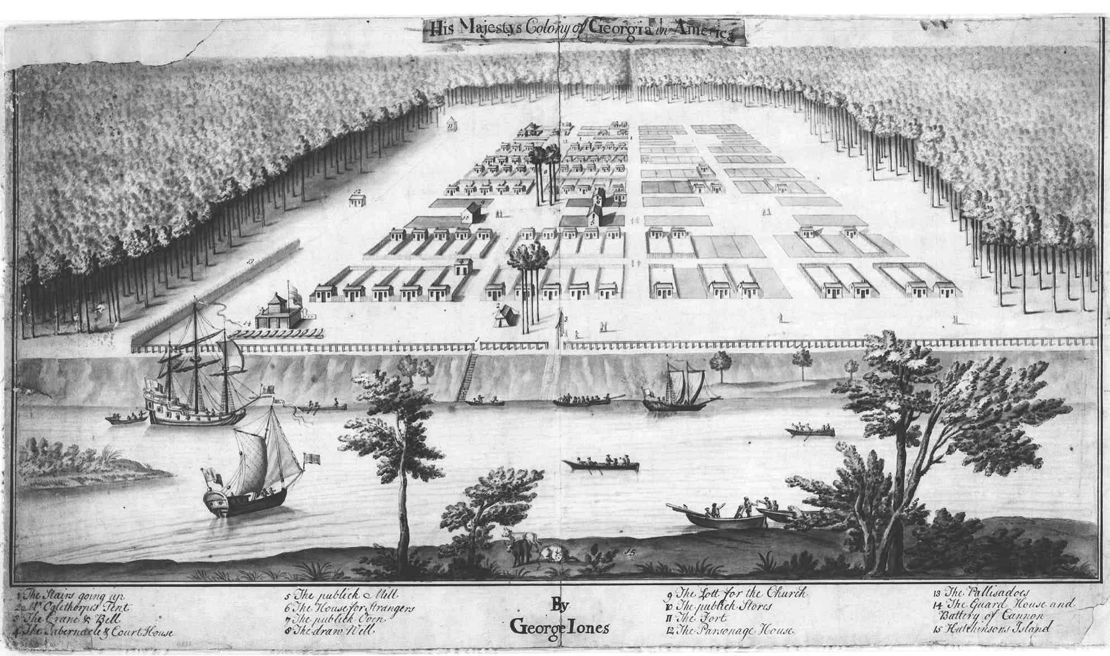Twenty trustees received funding from Parliament and a **charter** from the King, issued in June 1732. The charter granted the trustees the powers of a corporation; they could elect their own governing body, make land grants, and enact their own laws and taxes. Since the corporation was a charitable body, none of the trustees could receive any land from, or hold a paid position in, the corporation. Too, since the undertaking was designed to benefit the poor, the trustees placed a 500-acre limit on the size of individual land holdings. People who had received **charity** and who had not purchased their own land could not sell, or borrow money against, it. The trustees wanted to avoid the situation in South Carolina, which had very large plantations and extreme gaps between the wealthy and the poor.

The undertaking was **paternalistic** through and through. For example, the trustees did not trust the colonists to make their own laws. They therefore did not establish a representative assembly, although every other mainland colony had one. The trustees made all laws for the colony. Second, the settlements were laid out in compact, confined, and concentrated townships. In part, this arrangement was instituted to enhance the colony’s defenses, but social control was another consideration. Third, the trustees prohibited the import and manufacture of rum, for rum would lead

to idleness. Finally, the trustees prohibited Negro slavery, for they believed that this ban would encourage the settlement of "English and Christian" people.

Georgia's first year, 1733, went well enough, as settlers began to clear the land, build houses, and construct **fortifications.** Those who came in the first wave of settlement realized that after the first year they would be working for themselves. Meanwhile, Oglethorpe, who went to Georgia with the first settlers, began negotiating treaties with local Indian tribes, especially the Upper Creek tribe. Knowing that the Spanish, based in Florida, had great influence with many of the tribes in the region, Oglethorpe thought it necessary to reach an understanding with these native peoples if Georgia was to remain free from attack. In addition, the Indian trade became an important element of Georgia's economy.

It didn't take long, however, until the settlers began to grumble about all the restrictions imposed on them by the trustees. In part, this grumbling may have been due to the fact that most of those moving to Georgia after the first several years were from other colonies, especially South Carolina. These settlers viewed restrictions on the size of individual land holdings as a sure pathway to poverty. They also opposed restrictions on land sales and the prohibition against slavery for the same reason. They certainly did not like the fact that they were deprived of any self-government and their rights as Englishmen. By the early 1740s, the trustees slowly gave way on most of the colonists' grievances.

It is truly amazing that James Oglethorpe and the 20 Trustees attempted to create this over reaching utopian society. Our focus of this Mini-Q is to evaluate whether the Trustee Period was a success or failure as determined by the reasons for settlement as stated in the Charter of 1732. Examine the documents that follow and do your best to answer the question: *Were the reasons for the settlement, as stated in the Charter of 1732, a success or failure?*

**Background Essay Questions**

1. Define the following terms:

Buffer

Charter

Charity

Paternalistic

Fortifications

1. What were some of the motivating factors behind the creation of the Georgia Colony?
2. Who were some of the potential enemies that posed a threat to Georgia and the Carolinas?
3. What restrictions were placed upon the colonists who had received charity?
4. What were some of the policies that upset the colonists?

_______________________________________________________________________________________

1732 – King George II of England grants a charter giving the Trustees permission to establish the Georgia

Colony

1733 – James Oglethorpe and approximately 120 settlers arrive in Georgia and begin to construct the city of

Savannah

1734 – The first group of Salzburgers arrive in Georgia

1736 – The first group of Highland Scots arrive in Georgia

1739 – England declares war on Spain

1742 – Oglethorpe leads the colonists to victory over the Spanish at the Battle of Bloody Marsh

1752 – Georgia becomes a Royal Colony

**Understanding the Question and Pre-Bucketing**

1. What is the analytical question asked by this Mini-Q?
2. What years marked the beginning and end of Georgia’s Trustee Period? Use dates in the Background Essay to tentatively set these markers.
3. According to the Background Essay, what were the three reasons for the establishment of the Georgia colony?
4. Rewrite the question in your own words including the date.

**Pre-Bucketing**

Directions: Using any clues from the Mini-Q question and the document titles on the cover page, guess the analytical categories and label the buckets.



**Document A**

**Source:** Adapted from Coulter, E. M., and Albert B. Saye, eds. *A List of the Early Settlers of Georgia*.1949.

**Georgia's First Colonists**

Colonists Aboard the *Ann* Sent at Trustees' Expense:

|  |  |  |  |
| --- | --- | --- | --- |
| NAME | AGE | OCCUPATION | STATUS AS OF 1754 |
| Amatis, Paul | ? | Silk Maker | Dead, Dec. 1736 |
| Calvert, Mary | 42 | Wife of William | Dead, July 4, 1733 |
| Calvert, William | 44 | Trader in goods | No records after 1738 |
| Cannon, Clementine | 3 | Daughter to Richard | Dead, 1739 or earlier |
| Cannon, James | 7 mo. | Son to Richard | Dead, on Anne, Nov. 26, 1732 |
| Cannon, Mary | 33 | Wife to Richard | Dead, Jul 22, 1733 |
| Cannon, Richard | 36 | Carpenter | Dead, 1735 |
| Christie, Thomas | 32 | Merchant | In South Carolina? |
| Clark, Robert | 37 | Tailor | Dead, April 18, 1734 |
| Cox, William | 41 | Surgeon | Dead, April 6, 1733 |
| Cox, William | 12 | Son to William | To England, 1734 |
| Fitzwalter, Joseph | 31 | Gardner | Dead, Oct. 28, 1742 |
| Gordon, Katherine | 28 | Wife to Peter | To England |
| Gordon, Peter | 34 | Upholsterer | To England |
| Gready, John | 22 | Farmer | Apparently in S.C. |
| Hodges, Elizabeth | 16 | Daughter to Richard | Dead, Aug, 4, 1735 |
| Hodges, Mary | 42 | Wife to Richard | Apparently in GA |
| Hodges, Mary | 18 | Daughter to Richard | Dead, March 24, 1738 |
| Hodges, Richard | 50 | Basketmaker | Dead, July 20, 1733 |
| Jones, Mary | 3 | Daughter to Noble | In Georgia |
| Jones, Noble | 32 | Carpenter | In Georgia |
| Jones, Noble W. | 10 mo. | Son to Noble | In Georgia |
| Jones, Sarah | 31 | Wife to Noble | Probably dead, 1752 |
| Mackay, John | 25 | Servant to Joseph Stanley | Dead, July 25, 1733 |
| Stanley, Elizabeth | 35 | Widwife, Wife of Joseph | To England, Oct. 1736 |
| Stanley, Joseph | 45 | Stockingmaker, can draw and reel silk | Apparently still in GA |
| Waterland, William | 44 | Dealer in fabrics | To S.C., 1734 |

Colonists Aboard the *Ann* Who Came at Their Own Expense:

|  |  |  |  |
| --- | --- | --- | --- |
| Germain, Peter | ? | ? | Dead, July 13. 1733 |
| Horm, William | ? | ? | Arrested. Fled colony. |
| Macpherson, James | ? | Son to Captain Patrick | To S.C., Feb. 27. 1737 |
| Molton, Henry | ? | ? | In Georgia |

Note 1: This chart shows an excerpt of the *Ann*’s passenger list.

Note 2: In the summer of 1733, a Yellow Fever outbreak occurred due to the clearing of the pine forests on Yamacraw Bluff. This was caused when the slave sawyers, who were loaned to the new colony from the Governor of South Carolina, removed the tree stumps. What remained were depressions that collected standing water. This provided breeding areas for mosquitoes.

Note 3: It was estimated that one third of the original settlers lost their lives during that first summer. During the outbreak of Yellow Fever, James Oglethorpe allowed Dr. Nunes, a Jewish doctor who had recently arrived in Georgia, to treat the remaining affected colonists. To repay Dr. Nunes’ assistance, Oglethorpe allowed the settlement of Jewish immigrants in Savannah.

**Document B**

**Source:** The New Georgia Encyclopedia, *“War of Jenkins’ Ear”.*

Causes of the war centered on disputed land claims, but the conflict was not limited to land. Shipping on the high seas also suffered frequent interruption from acts of piracy by both sides. One particular incident gave the confrontation its name: a Spanish privateer severed British captain Robert Jenkins's ear in 1731 as punishment for raiding Spanish ships. Jenkins presented the ear to Parliament, and the outraged English public demanded retribution. General James Oglethorpe made several passes into Florida in January 1740 and seized two Spanish forts, Fort Picolata and Fort San Francisco de Pupo, west of St. Augustine, Florida, along the St. Johns River. He began a strike against the fort at St. Augustine in May 1740, but the campaign was a failure. Oglethorpe wanted to seize the fort before Spanish supplies or reinforcements could arrive, but problems with multiple commanders and diverse forces resulted in disorganization, spoiling his advantage of surprise. Oglethorpe settled for a traditional siege of the fort but failed to coordinate his land and naval forces. By early July he discontinued the attack, retreated to Fort Frederica and waited for a Spanish invasion.   
 That assault came in the summer of 1742. After landing on the southern tip of St. Simons Island, the Spanish assembled for an attack on Frederica. English rangers encountered a scouting party, and Oglethorpe led the charge against the Spanish soldiers, who hastily fled the scene. While Oglethorpe returned to Frederica, his men fortified the road to the fort to prevent further incursions. A second skirmish ensued, an event later known as the Battle of Bloody Marsh, when the Spanish advanced another regiment. English forces sent the Spanish fleeing to the coastline and from there retreating to St. Augustine. Oglethorpe prepared another offensive upon the fort at St. Augustine in March 1743, but his efforts had little result and represented the last episode of the war on the Georgia-Florida border. The Treaty of Aix-la-Chappelle in 1748 returned all colonial claims to previous owners, and the two nations unofficially agreed upon the St. Johns River as the boundary between Georgia and Florida.

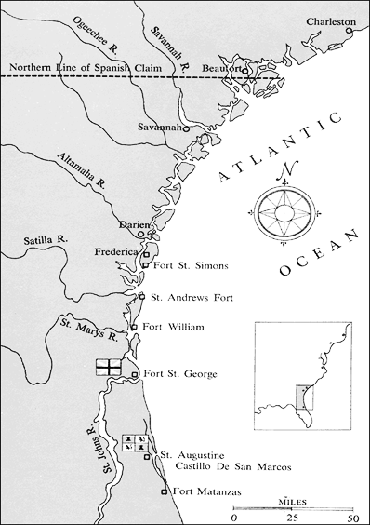

**Source:** National Park Service

**Territory Claimed by British and Spanish during**

**Georgia’s Colonial Period with Location of Major**

**Settlements and Forts**

**Document C**

**Source:** Georgia Historical Society, *Eighteenth Century,* 2012

In 1733, General James Oglethorpe, acting on behalf of the Trustees for the Establishment of the Colony of Georgia in England, landed a group of colonists and settled the town of Savannah in the new colony of Georgia.  Georgia was established in part as an experiment, based on ideals lost in the other colonies' growth, as well as to provide the mother country with raw goods.  The southern location and warm climate of Georgia led many to believe it would be suitable for the cultivation of silk and fruits.

The seal used by the Trustees represented the colony's role within the British Empire, as well as its emphasis on the production of silk.  The seal incorporated a black mulberry leaf with a silkworm and cocoon (mulberry leaves were used to feed the silkworms in sericulture, the cultivation of silk).  The motto inscribed was "Non sibi sed aliis," Latin for "Not for themselves but for others."  The seal and motto are a symbol of Georgia's role as a mercantile colony established to be the source of silk, not for their own benefit, but for England's.

**The Official Seal of the Trustees for the**

**Establishment of the Colony of Georgia**

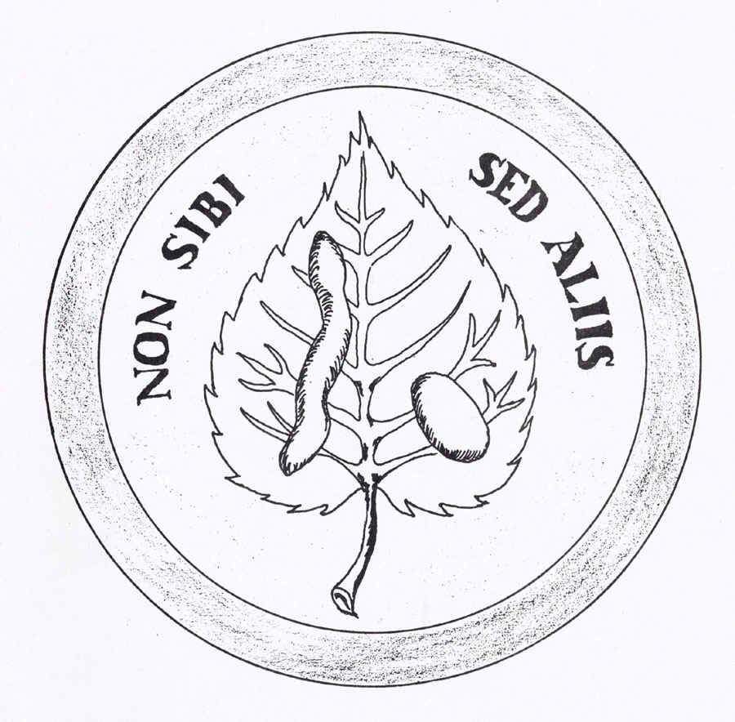

Note: In 1735 Queen Caroline of England wore a dress made of imported Georgia silk to celebrate her fifty-second birthday. By 1742 Georgia silk had become an important export commodity, and by 1767 almost a ton of silk was exported to England each year (Georgia Encyclopedia).

**Document D**

**Source: *The Federal and State Constitutions Colonial Charters, and Other Organic Laws of the States, Territories, and Colonies Now or Heretofore Forming the United States of America Compiled and Edited Under the Act of Congress of June 30, 1906* by Francis Newton.**

**Charter of Georgia: 1732**

GEORGE the second, by the grace of God, of Great Britain, France and Ireland, king, defender of the faith, and so forth. To all to whom these presents shall come, greeting.   
  
Whereas we are credibly informed, that many of our poor subjects are, through misfortunes and want of employment, reduced to great necessity, insomuch as by their labor they are not able to provide a maintenance for themselves and families; and if they had means to defray their charges of passage, and other expences, incident to new settlements, they would be glad to settle in any of our provinces in America where by cultivating the lands, at present waste and desolate, they might not only gain a comfortable subsistence for themselves and families, but also strengthen our colonies and increase the trade, navigation and wealth of these our realms. And whereas our provinces in North America, have been frequently ravaged by Indian enemies, more especially that of South-Carolina, which in the late War, by the neighboring savages, was laid waste with fire and sword and great numbers of English inhabitants, miserably massacred, and our loving subjects who now inhabit them, by reason of the smallness of their numbers, will in case of a new war, be exposed to the late calamities; inasmuch as their whole southern frontier continueth unsettled, and lieth open to the said savages. And whereas we think it highly becoming our crown and royal dignity, to protect all our loving subjects, be they ever so distant from us; to extend our fatherly compassion even to the meanest and most unfortunate of our people, and to relieve the wants of our above mentioned poor subjects; and that it will be highly conducive for accomplishing those ends, that a regular colony of the said poor people be settled and established in the southern territories of Carolina. And whereas we have been well assured, that if we will be most graciously pleased to erect and settle a corporation, for the receiving, managing and disposing of the contributions of our loving subjects; divers persons would be induced to contribute to the uses and purposes aforesaid-Know ye therefore, that we have, for the considerations aforesaid, and for the better and more orderly carrying on of the said good purposes; of our special grace, certain knowledge and mere motion, willed, ordained, constituted and appointed, and by these presents, for us, our heirs and successors, do will, ordain, constitute, declare and grant, that our right trusty and well beloved John, lord-viscount Purcival, of our kingdom of Ireland, our trusty and well beloved Edward Digby, George Carpenter, James Oglethorpe, George Heathcote, Thomas Tower, Robert Moore, Robert Hucks, Roger Holland, William Sloper, Francis Eyles, John Laroche, James Vernon, William Beletha, esquires, A. M. John Burton, B. D. Richard Bundy, A. M. Arthur Bedford, A. M. Samuel Smith, A. M. Adam Anderson and Thomas Corane, gentlemen; and such other persons as shall be elected in the manner herein after mentioned, and their successors to be elected in the manner herein after directed; be, and shall be one body politic and corporate, in deed and in name, by the name of the Trustees for establishing the colony of Georgia in America…  
  
By writ of privy-seal.

Note: Of the approximately 114 individuals who became Georgia’s first settlers, none were documented as having been released from debtor’s prison.

**Document E**

**Source:** Patrick Tailfer. *A True and Historical Narrative of the Colony of Georgia*, 1835.

It only remains, that we in a few Paragraphs endeavor to exhibit to the View of the Reader, the REAL Causes of the Ruin and Desolation of the Colony; and those briefly are the following:

1. The Representing the Climate, Soil, &c. of Georgia in false and too flattering Colours; at least, the not contradicting those Accounts when publickly printed and dispers’d, and satisfying the World in a true and genuine Description thereof.
2. The Restricting too much the Extent of Possessions; it being impossible that fifty Acres of good Land, much less Pine Barren, could maintain a white Family.
3. But chiefly Denying the Use of Negroes, and persisting in such Denial after, by repeated Applications, we had humbly remonstrated the Impossibility of making Improvements to any advantage with white Servants.
4. The Neglecting the proper Means for Encouraging the Silk and Wine-Manufactures; and disposing of the liberal Sums contributed by the Publick, and by private Persons, in such ways and Channels as have been of little or no Service to the Colony.
5. The Assigning certain fix’d Tracts of Land to those who came to settle in the Colony, without any regard to the Quality of the Ground, Occupation, Judgment, Ability or Inclination of the Settler, &c. &c. &c.

By these and many other Hardships, the poor Inhabitants of Georgia are scatter’d over the Face of the Earth; her Plantations a Wild; her Towns a Desert; her Villages in Rubbish; her Improvements a By-Word, and her Liberties a Jest: An Object of Pity to Friends, and of Insult, Contempt and Ridicule to Enemies.

Note1: It was a common practice of writers in the 18th Century to capitalize the first letters of words to which they wanted to draw the reader’s attention or when they wanted to emphasize importance.

Note 2: The above list of 5 grievances was excerpted from a list of 15.

**Document F**

**Source**:*Jews of Savannah,* B. H. Levy and Rabbi Arnold Mark Belzer.

**The Hope of Israel**

Forty-two brave pioneering Jews, the “largest group of Jews to land in North America in Colonial days” arrived in Savannah on July 11, 1733, just five months after General James Edward Oglethorpe established the colony of Georgia. Although the trip on the William and Sarah was rough, and they ran aground near North Carolina, the new colony continued to provide hope for those “industrious” poor [Sephardic](http://www.jewishvirtuallibrary.org/jsource/Judaism/Sephardim.html) and [Ashkenazic](http://www.jewishvirtuallibrary.org/jsource/Judaism/Ashkenazim.html) Jews in London who had been living in difficult circumstances.

In 1732 there were 6,000 Jews living in London. The more affluent and established members of that Jewish community, threatened by the poverty of their coreligionists, provided generous financial support by subscribing to Oglethorpe’s new colony of Georgia, in addition to helping their fellow Jews set sail on the second boat for Georgia. Among the Jews who helped subscribe were members of the [Spanish](http://www.jewishvirtuallibrary.org/jsource/vjw/Spain.html) and Portuguese Bevis Marks Synagogue, the mother congregation to Mickve Israel in Savannah.

These founders of Mickve Israel brought with them a “Safertoro” [sic] made of deerskin, with two “cloaks,” and a “circumcision box,” which was donated by a London merchant. This Torah is still used on commemorative occasions at Mickve Israel.

All but eight of the original forty-two Jewish colonists were Spanish/Portuguese Jews who had arrived in London ten years earlier, having lived as Crypto-Jews, publicly practicing Roman Catholicism and secretly preserving their Jewish heritage, prior to their departure from Portugal. Among these sephardic Jews was Dr. Samuel Nunes Ribiero, a physician who had been imprisoned during the Inquisition for his successful efforts to convert New Christians back to the Jewish faith. Of the eight Ashkenazic founders were the families of Abraham Minis and Benjamin Sheftall, whose descendants are benefactors and active participants in the congregation today.

Savannah’s Jewish community followed a sequence different from the two older Jewish communities in New York (1654) and Newport (1695), and markedly different from the newer colonial Jewish settlements in Philadelphia (1739) and Charleston (1749). The primary act of the Savannah settlers was the founding of a congregation, then the establishment of a cemetery, followed by a “mickvah,” or ritual bath (on April 2, 1738).



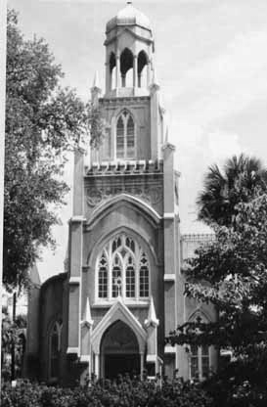

**The Early Savannah Congregation**

Upon settling in Georgia, the Savannah Jews probably held services in the homes of members. In July 1735 they “met together, and agreed to open a Synagogue…which was done immediately, named K. K. Mickva Israel” (Kahal Kodesh Mickva Israel which is translated as Holy Congregation Hope

of Israel).

**Mickva Israel, Savannah, Georgia**

**Document G**

**Source:** Adapted from Benjamin Martyn, *An Impartial Enquiry into the State and Utility of the Province of Georgia*. Oxford University,1741.

“…That the Climate of Georgia is very healthy, there being Quantities of running Water, and constantly fine Breezes from the Sea in the Middle of the hottest Days… That the Climate and Soil is very fit for raising Silk, Wine and Cotton; for that the white Mulberry-Trees thrive exceeding well, as also the Vines, which have been cultivated there, bear exceeding good Grapes.”

**1)**

Note: This statement was one of many collected from persons who had lived in or passed through the Georgia Colony. This particular statement was sworn before a public office by Samuel Augspourguer, of the Canton of Berne in Switzerland as he was returning to Switzerland to guide additional Salzburgers to Georgia.

**Source:** National Humanities Center, Journals of P.G.F. von Reck and Rev. J.M. Bolzius, 1734, excerpts.

From von Reck:

**Sunday, March 17**. … The Lands are enclosed between two Rivers which fall into the Savannah. The Saltzburg Town is to be built near the largest, which is called Ebenezer, in Remembrance that God has brought us hither; and is navigable, being twelve Foot deep. A little Rivulet, whose Water is as clear as Crystal, glides by the Town; another runs through it, and both fall into the Ebenezer.

From Reverend Bolzius:

**Friday, March 29.** Yesterday and today we had cold Weather, which is very surprising to us, because the Weather hath for some time been rather too hot. This cold Weather is a Blessing of God since the vermin and little flies, which incommoded us much, have been destroyed thereby…

**2)**

Note: The above are two entries from journals that were kept by members of the first group of Salzburgers to arrive in Georgia and who helped establish the settlement of Ebenezer. It should be noted however that the settlement was abandoned after two years due to the fact that there was no accessible water passage to the Savannah River. Ebenezer was too far inland, and it was an eight-mile journey to the nearest town for provisions. Also, because of the swampy conditions, livestock could not thrive and roughly thirty Salzburgers died from dysentery. Upon Rev. Bolzius, the leader of the Salzburgers’ request, Oglethorpe granted them land on a high bluff along the Savannah River. The new settlement was called New Ebenezer.

**Bucketing – Getting Ready to Write**

Look over all the documents and organize them into your final buckets. Write final bucket labels under each bucket and place the letters of the documents in the buckets where each belongs. It is legal to put a document in more than one bucket. That is called multi-bucketing, but you need a good reason for doing so. Remember, your buckets are going to become the body paragraphs for your final essay.

  

**Thesis Development and Roadmap**

On the chicken foot below, write your thesis and create your roadmap. Your thesis is always an opinion and answers the Mini-Q question. The roadmap is created from your bucket labels and lists the topic areas you will examine in order to prove your thesis.



From Thesis to Essay Writing: Mini-Q Essay Outline Guide

**Working Title**

**Paragraph #1**

Grabber

Background

Stating the question with key terms defined

Thesis and road map

**Paragraph #2**

Baby Thesis for bucket one

Evidence: supporting detail documents with document citation

Argument: connecting evidence to the thesis

**Paragraph #3**

Baby Thesis for bucket two

Evidence

Argument

**Paragraph #4**

Baby Thesis for bucket three

Evidence

Argument

**Paragraph #5**

Conclusion: restatement of main idea along with possible insight or wrinkle