D.R.A.W. – Causes of the
Name: __________________________
Date: __________ Period: __________
American Revolution

Document Based Question: What were the immediate
and long term causes of the American Revolution?
Part I – Reading Article: American Revolution
"American Revolution." Britannica School. Encyclopædia Britannica, Inc., 2013. Web. 4 Oct. 2013. <http://school.eb.com/levels/middle/article/353711>.

American Revolution
The American Revolution was the war in which Great Britain’s 13 American colonies won their independence. The colonies became a new country, the United States. The revolution began in 1775 and ended in 1783.

Background
Before the 1760s the colonies had a lot of freedom even though they were under British rule. The British government was across the Atlantic Ocean, more than 3,000 miles (5,000 kilometers) away. The colonies had their own leaders and learned to solve their own problems. Plus, because Britain was often at war, it did not always pay close attention to the colonies.

In the 1760s, however, the British government tried to take more control over the colonies. One major reason for this change was the French and Indian War. Britain defeated France in the war in 1763. But the war had been very costly. Afterward, Britain decided that its American colonies should help to pay its debts. In addition, the Proclamation of 1763, issued by King George III, angered many colonists by reserving land west of the Appalachian Mountains for Native Americans, instead of increasing the land area of the colonies.

Taxes
To raise money, Britain forced the colonies to pay new taxes. In 1765 the British lawmakers, called Parliament, passed a law called the Stamp Act. The act put a tax on legal papers, newspapers, and other printed items. The colonists protested against the tax. They were especially angry because Parliament was taxing them even though they had no representatives in Parliament. Because of the protests, the British government ended the tax in 1766.

In 1767, however, a British official named Charles Townshend got Parliament to pass several new tax laws. The Townshend Acts taxed tea, lead, paint, paper, and glass coming into colonial ports. These taxes made the colonists even angrier.
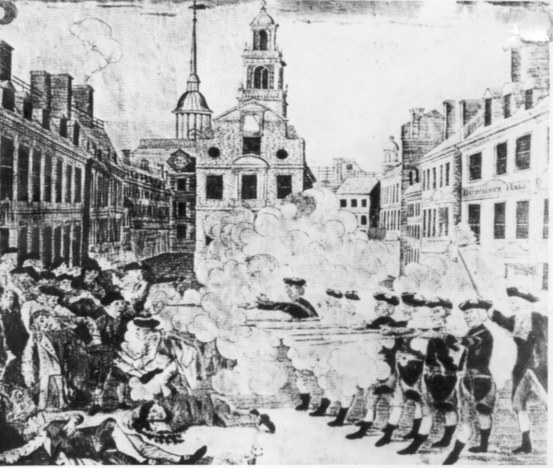
Boston Massacre and the Tea Party
To keep order, the British government sent soldiers to Boston, Massachusetts. On March 5, 1770, British soldiers fired shots into a crowd. Crispus Attucks and several other Americans were killed. This event became known as the Boston Massacre.

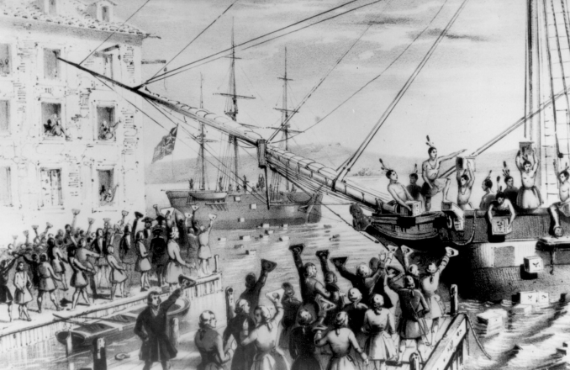
On the same day as the Boston Massacre, Parliament did away with most of the Townshend Acts. They kept a tax on tea, however. Then, in 1773, Britain passed a law that allowed a British company to sell tea more cheaply than colonial merchants. On December 16, 1773, colonists boarded British ships in Boston Harbor and threw their cargo of tea into the water. This event became known as the Boston Tea Party.

Intolerable Acts
The British government then passed laws that were even harsher. The colonists called them the Intolerable Acts. The strongest of these acts closed the port of Boston until the colonists paid for the tea they had ruined. Massachusetts was put under military rule.

The colonists realized that the colonies had to act together. In 1774 representatives from every colony except Georgia met in Philadelphia, Pennsylvania. The meeting was called the Continental Congress. The representatives called on Britain to cancel the Intolerable Acts. The British government answered by sending in even more troops.
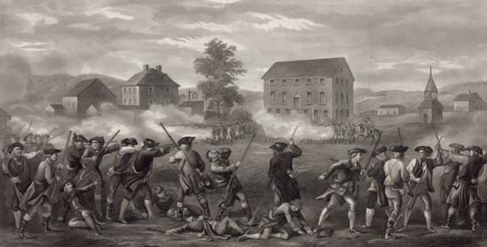
Early Battles
By this time many colonists believed that their problems with Britain could not be worked out peacefully. They prepared to fight. They formed groups of soldiers called minutemen. The minutemen were to be ready to fight “at a minute’s warning.”

In April 1775 Britain sent a force to seize the colonists’ military supplies in Concord, Massachusetts. Paul Revere and William Dawes rode through the countryside to warn the colonists that the British soldiers were coming. On April 19 a group of minutemen met the British in Lexington, a town on the way to Concord. After a short fight, the British moved on to Concord. Another group of American soldiers forced them to turn back. The Battles of Lexington and Concord began the American Revolution.

The Second Continental Congress met in Philadelphia in May 1775. It brought together the military forces of the colonies to form the Continental Army. It put George Washington in charge of the army. Washington spent months preparing his troops for battle.

Meanwhile the first major battle of the war took place at Bunker Hill, near Boston. The British captured Bunker Hill on June 17, 1775. But they lost so many soldiers that the colonists claimed victory. The battle was very encouraging to the colonists.

Before 1776, most colonists did not want to break free from Britain. They only wanted to get Britain to do something about their complaints. But as the fighting spread, more colonists became convinced that they had to separate from Britain. On July 4, 1776, the Continental Congress approved the Declaration of Independence. With this document, the 13 colonies became the United States of America.

