Dear Parents/Guardians,

This week in science, your child is exploring states of matter. Throughout the week we will be talking about solids, liquids, and gases. We will also discuss how they change into different states depending on the temperature. This activity is a great hands-on experiment for your child to learn more about changing states of matter! Directions are listed below!

Materials Provided:
1. 2 Balloons (caution-may be a choking hazard to little ones!)

Directions:
1. Fill both balloons with different amounts of water (larger and smaller) and tie them.
2. Place both balloons in the freezer overnight, or for 8+ hours.
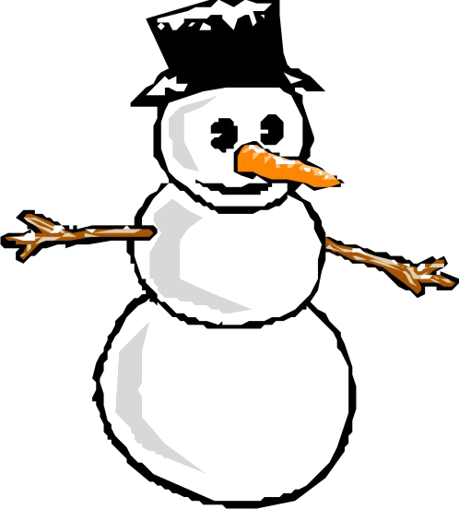
3. After 8 hours, take the balloons out of the freezer. Using scissors cut the top of the balloon covering off of the ice. Peel off the outside of the balloon, so only the ice remains.
4. Leave ice in a container and watch them melt over time.
5. Record how long it takes both balls of ice to melt.

*** Ask your child questions along the way:
-Which ball do you think will melt faster? Why?
-Which ball of ice was made out of the most water?
-How long do you think it will take the ice to melt?
-What state of matter is the water changing to?

