**General Safety Rules Crossword Puzzle**

MCj03709100000[1]Directions: Use your “General Safety Rules” to complete the following

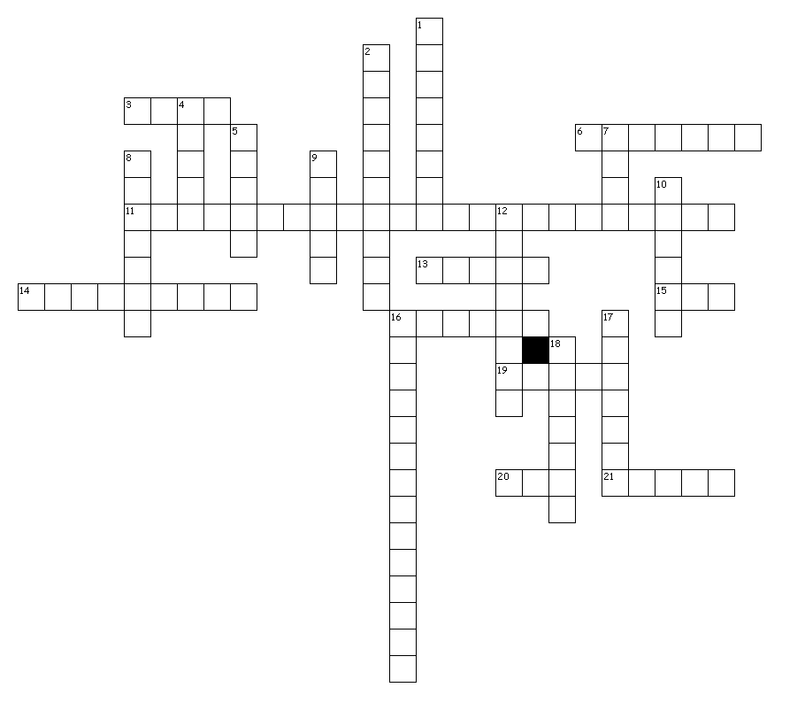

Down

1. Develop a safe ________.

2. When working with hazmats, work in a well-________ area.

4. Always use the ______ tool for the job.

5. To avoid injury, use a machine _____ if available.

7. Lift with your _____ and not your back.

8. Do not use electrical tools or equipment if the cord or plug is _____.

9. Follow safety ______ for all of the machines.

10. Stay out of danger zones marked with black and ______-striped tape.

12. Do not let others ______ you while you use a machine.

16. You should consider everyone's safety to be your ________.

17. Keep hands and _______ away from all moving parts.

18. You should report accidents to your _______ immediately.

Across

3. Store oily rags in a metal container to prevent ______.

6. Always wear safety ______ in the wood shop.

11. This document (MSDS) contains safety information about a substance or product.

13. Use a _____, not your hands to clean dry materials from the work surface.

14. Never engage in _________.

15. Before leaving a machine, you should turn it ____.

16. You should ______ all tools to their proper places.

19. After using a machine, you should turn it off and ______ the area around it.

20. Short for personal protective equipment

21. Handle materials with ______ edges cafefully.